Determining which statistics have the most significant influence on tennis match outcomes
Author: Luca Pavan
Supervisor: Alexa Laurence
Submitted in partial fulfillment of the requirements of the degree of
MSc Data Science, University of Kent, 2025

Acknowledgements
I would like to express my gratitude to my supervisor, Dr. Alexa Laurence, for her support throughout this master’s project, which provided me with valuable ideas to explore and enabled me to produce a more detailed and structured report. Additionally, thanks to Jeff Sackmann for creating open-source tennis datasets that are well-structured and ready for analysis.

Summary
My analysis has shown that when breakpoints are demonstrated as the number converted, they are the most crucial feature in explaining the outcome of a tennis match. However, when this is changed to conversion percentage or the number of chances a player has, it is no longer the most critical variable. The 1st serve percentage points won becomes the most crucial feature, with a variable importance of 33% for both players, and it is closely followed by the 2nd serve percentage of points won, with a variable importance of 28% for both players. Within the importance of this feature, similar weight was given to both the player and the opponent in predicting the match outcome, demonstrating that it is not only about how a player handles their service games, but also the effect they can have on their opponents. Ten predictors were included in many final models, with a 1-unit change compared to the mean, in the 1st serve percentage points won, contributing to a 7% increase in win probability, while keeping all other variables constant. The 2nd serve percentage points won contributed to a 4% increase in win probability. Mean values for the 1st and 2nd serve percentage points won were 72% and 51% respectively. Regarding models investigating the proportion of points won, the difference between the player and opponents resulted in a better model fit.
Modelling accuracy using the provided variables showed a 97% cross-validation prediction accuracy, indicating that the variables are highly effective in explaining the outcome of matches. Non-linear relationships were confirmed for some service variables, showing low changes in predictive outcome for high and low percentage values. Confirming that tennis is a sport played with small margins, separating the differences between winning and losing.
Predictive Modelling using prior results and rolling averages for both players and opponents from the previous five matches showed a cumulative accuracy value of 75% and a cumulative AUC of 83%. This results in a strong model performance for future data and could be used to aid betting predictions.

Contents
- Introduction
- Main Body
  - Literature Review
    - Introduction
    - Player Performance and Ranking Systems
    - Predictive Modelling of Match Outcomes
    - Point and Shot Level Modelling
    - Conclusion and Future Research
  - Data Set
- Discussion
  - Data Cleaning
  - Exploratory Data Analysis (EDA)
    - Method
    - Results
  - Data Modelling
    - Method
    - Results
  - Regularisation
    - Method
    - Results
  - Generalised Additive Models
    - Method
    - Results
  - Bayesian Modelling
    - Method
    - Results
  - Predictive Modelling
    - Method
    - Results
  - Future Research
References
Appendices
1 Introduction
Tennis is among the most thoroughly analysed sports, with numerous statistics detailing player performance and match results. Serve percentages and breakpoint conversions, as well as shot speeds and contact locations, all provide detailed data to help understand success on the court. Despite this, it is crucial to determine which statistics have the most significant impact on match outcomes. Recognising the key features can improve the viewer's understanding and support coaching, player development, and performance prediction.
The primary objective of this project is to identify which match-level statistics are most strongly correlated with winning outcomes in men's professional tennis. This objective will be addressed by reviewing existing research on tennis analytics, examining common performance indicators, and analysing data from the ATP 2024 season. The analysis will include data cleaning, exploratory data analysis, and the application of multiple modelling techniques such as regression, regularisation, generalised additive models, Bayesian inference, and predictive modelling.
This investigation aims to determine which performance metrics reliably predict match outcomes. The findings are expected to contribute to sports analytics research and inform practical applications in performance optimisation.
2 Main Body
2.1 Literature Review
A Thematic Review of Data Modelling Approaches in Tennis Analytics
2.1.1 Introduction
The use of data modelling in sport has become increasingly popular over the last two decades, with numerous studies finding ways to improve by analysing what separates the top athletes from the rest. The introduction of more readily available data enables people to identify patterns and trends, which can be presented to coaches and athletes and used to predict outcomes for financial gain. In tennis, the use of tracking technologies such as Hawk-Eye enables analysts to track the locations of rally balls with varying trajectories and velocities. This provides even more detailed insight into how top players make it so difficult to play against them. Using statistics, researchers have been able to interpret how match outcomes can be predicted, the relationship between match statistics and player rankings, and point or shot-level modelling. Throughout this literature review, I will examine how these thematic areas have benefitted tennis enthusiasts by reviewing their methodological approaches, results, and the strengths and limitations of their research. This will enable me to understand both the interesting results and the methodological challenges that these researchers have encountered while completing their work.
2.1.2 Player Performance and Ranking Systems
The official ranking system in men’s tennis is the ATP (Association of Tennis Professionals) and is calculated over a yearly span. A player’s ranking will include all the points they have accumulated from ATP events on a rolling year basis. This ranking system can have its flaws, as players who become injured can quickly drop down the rankings depending on the duration of their absence from competition. This could then make it difficult for them to return to competitive tennis, as only a select number of players are allowed to compete in specific events. Wild cards and protected rankings are in place to help players return; however, this will not impact tournament seedings or draws. Gorgi, Koopman, and Lit (2019) investigated creating a different ranking system based on the performance of tennis players and had a strength rating which changed due to the various surfaces: hard, grass, and clay, as there are significant differences in the speed of the surfaces, and how that can affect gameplay styles. Reid, McMurtrie, and Crespo (2010) investigate the statistical relationship between match statistics and the top 100 ranking. They found that second serve points won, and second serve return points won were the most influential for increasing a player’s ranking. Whilst log-transformed aces, first serve returns points won, and first serve % also contributed, but only increased the variance by 7%. They established some notable differences between the top 10 and the top 100 players. With the best players increasing their service games won from 80% to 83% and return games won from 23% to 28%. As well as second serve points won, and second serve return points won were 10% higher for both metrics. This work can be an asset to players and coaches, as it highlights the importance of improving a player’s return of serve and showcases the differences between elite tennis players.
Bozdech, Puda, and Grasgruber (2024) also investigated statistics with ranking and employed machine learning models, including multivariate analysis of variance and multinomial logistic regression. Their findings included first-serve points won and return percentage made as the most crucial features for winning a tennis match. Ma, Liu, and Tan (2013) employed a logistic regression model to identify the most critical features that determine the outcome of a tennis match and how these features influence the chances of winning. First-serve points won emerged as the most crucial feature, with an odds ratio of 1.27, followed by second-serve points won, which had an odds ratio of 1.17. Interestingly, they found that the breakpoints' advantage disappeared when distinctions between the player and their opponent were taken into account.
2.1.3 Predictive Modelling and Match Outcomes
Early tennis forecasting models treated player ability as static; however, more recent research has highlighted the importance of modelling over time. This is due to tennis being a form-related sport, which can add more emphasis to recent results, as players often experience intense periods of play and gain confidence, compared to results from months prior. Although models can now predict outcomes over time, there has been no successful research on generating positive returns; instead, they are used to inform and debate the topic. This could be due to the proprietary nature; if someone created something with a positive impact, they would likely keep it for financial gain and sell it to others, rather than making it readily available for use. Another reason could be the lack of current data; many websites have statistics available from previous years; however, this is not helpful when trying to create a live model that performs over time, as recent match performances are crucial in understanding the player's form and that of their opponent. Results from years past can provide historical data and head-to-head comparisons between players, although they miss the defining edge of what is happening in that present moment.
Klassen and Magnus (2003) developed a predictive model using rankings and seedings, while Clarke and Dyte (2000) employed the difference in rankings. Later, Mchale (2011) developed a Bradley-Terry model that gives greater weight to recent results. They also considered the scoreline between players, considering the ease of win factor, which depended on how many games each opponent had won. This was updated weekly to keep the model as current as possible. The model also considered the surface on which the matches were played. Matches played on the same surface were given more substantial weight than matches on different surfaces. They used the last 3 years of data and achieved an accuracy of 66% in predicting the outcome. Although the model did not consider alternating service games within a tennis match, so there was a lack of dependence between games.
Gorgi et al. (2018) also developed a model using an ELO rating for each player. This rating changed with every match, increasing with a win and decreasing with a loss. This also considered the ELO of the opponent and changed more aggressively when losing to a lower-ranked ELO opponent and vice versa. Their scale had a baseline ELO and three additional ELO ratings depending on the surface of the current match. Grand slams had added weight due to the increase in the number of sets that have to be won to win a match. This would enhance the ELO ratings of top players, as the Big 3 dominated Grand Slam tournaments. Their predictions also achieved a similar prediction accuracy of 69%.
2.1.4 Point and Shot Level Modelling
More granular modelling focuses on point and shot-level events to uncover tactical insights and biomechanical determinants of success. Mecheri, Rioult, Mantel, Kauffmann, and Benguigui (2016) conducted the first large-scale statistical and spatial analysis of serve performance using Hawk-Eye tracking data. They used factors such as ball trajectory, serve speed, surface, sex, and serve location to analyse the importance of the serve in elite tennis. This study was conducted between 2003 and 2009, utilising data from the Grand Slam tournaments. This was limited to only specific tournaments that had access to this tracking technology. Results established the key differences in how the serve affects the outcome, depending on the surface. The study found that only 14% of points are completed at the baseline on grass, but 68% on clay. At Wimbledon, 97% of points were finished under five shots, whereas on clay, 61% of shots were finished under five shots. Emphasising that grass court tennis is extremely serve-dominated, making it easier to predict outcomes. Clay court tennis relies on the aspects within the rally due to its slower speed and more effortless movement.
Serve speed was negatively correlated with serves made but positively correlated with service points won when made. Highlighting the trade-off between serving faster and ensuring the serve is made. First serve locations were directed into the corner to put the opponent under pressure with a stretched return. Second serve locations were all directed to the backhand, as this is a weaker shot in comparison to the forehand, and stops pressure coming straight from the return.
In women’s tennis, this differed slightly in terms of second serve locations, with more being to the body as well as the backhand. This could be because women struggle more when the ball comes close to their body, whereas men are more eager to move and get a forehand in play. This study may encourage players to focus on their backhand returns when facing a second serve, aiming to gain an immediate advantage. The use of data with return analysis can be highly beneficial for comparing the differences between the serve and return and identifying what has the most significant impact on the match outcome, especially since players win their service games 80% of the time.
To further investigate the effects of rallies and shot patterns, Makino, Odaka, Kuroiwa, Suwa, and Shirai (2020) examine how shot types influence the ability to win points. They employed machine learning classification and feature selection to understand the relationships between shot patterns. The most important finding was the ratio of specific shots; however, I feel this is quite a broad feature, as the shot and direction are not known. Other findings include that in Djokovic v Murray matches, Djokovic won the highest ratio of points when hitting into Murray’s backhand. This point-level insight could be helpful when analysing previous matches against the same opponent to determine how a player won and lost points. Players and coaches can use this to devise game plans using players’ strengths while exploiting their opponents’ weaknesses.
2.1.5 Conclusion and Future Research
Across these studies, a clear trend emerges toward the increasing use of dynamic modelling approaches in tennis analytics. Dynamic modelling and hybrid machine learning frameworks have improved predictive performance over static models; however, these require a substantial amount of data and sophisticated computation. More enhanced models may be hidden for financial gain, and accessing high-quality recent data can be complex due to companies’ unwillingness to share. Studies linking performance metrics to rankings show that specific match statistics are key indicators of the difference between players at the top of the game. However, generalisation beyond the top tier of men’s professional tennis is limited. Point and shot level analyses, whether focused on serve performance or rally characteristics, understand the tactical element needed for success; however, they have focused on isolated aspects of play without showing the full match context.
Future research could expand on the existing studies of women’s tennis, lower-level men’s tennis, and juniors to provide a comprehensive range of statistical research applicable to all sexes and standards. Although this data is limited, it could be even more helpful to establish coaching plans for junior players, as the serve has a less dominant impact on the game. Other research could include the physiological and psychological aspects of the game and how they impact various moments in a match. These studies provide actionable insights for players and coaches, and I aim to expand on this scope by offering my own detailed analysis.
2.2 Data Set
The dataset analysed throughout this project is the ATP 2024 matches. This was downloaded from GitHub and created by Jeff Sackmann, a tennis data enthusiast. This dataset was chosen because it is the most recent data available, which is essential when analysing sport, as the style of play can adapt significantly over time. Variables included in the dataset were: player names, tournament name and date, outcome, match number, draw size, surface, tournament seeding, ranking, score, best of (sets), heights, ages, player country, player hand, minutes, 1st serves in, 1st serve points won, 2nd serve points won, aces, double faults, service points, service games, break points saved, break points faced. The initial dataset consisted of 3076 observations and 50 variables.
3 Discussion
3.1 Data Cleaning
Data cleaning was a crucial step in preparing the ATP dataset for exploratory analysis and modelling. Raw match data often contains many missing values and duplicate records; these need to be addressed to ensure data can be analysed accurately. The cleaning process was carried out in R, using the tidyverse package to ensure consistency and clarity.
After loading the dataset, the first step was to understand its structure. The dimensions were examined to determine the number of matches and variables. Then, the data type of each column was identified to determine which model would be used for analysis. This step also ensured that features were classified adequately before further preprocessing. A unique match ID column was created to facilitate the identification of matches. This allowed for easy access to change values within rows if incorrect data was seen.
Missing values (NA) were systematically identified with the summary() function. Different strategies were employed depending on the variable and its potential impact on the model. Tournament seed variables (winner seed, loser seed): NAs were expected due to limited seeding in tournaments. These were retained in the dataset, as they do not affect the modelling of match outcomes. Player characteristics (height, age): Some missing values arose from wildcard entrants or players without complete online records. These were preserved for descriptive analysis but excluded from models where player-level features were central to the study. Ranking points: In rare cases, NAs appeared due to players from Davis Cup matches, not playing on the ATP tour. These rows were later removed when incorporating ranking differences into models. Match duration (minutes): Since this variable was considered important for performance modelling, rows with missing match duration were removed after exploratory data analysis. Serve statistics: NAs in serve-related variables were deemed critical, as these features are central to the research objective. All matches with missing serve data were excluded from the final modelling dataset.
To improve the interpretability and usefulness of the dataset, several new variables were created:
First Serve Percentage = (First Serves In ÷ Total Serves) × 100
First Serve Points Won percentage = (First Serve Points Won ÷ First Serves In) × 100
Second Serve Points Won percentage = (Second Serve Points Won ÷ Second Serves In) × 100
Break Point Conversion percentage = (Break Points Won ÷ Break Points Faced) x 100
As well as others included for data analysis and point level modelling, including Total points won, total match points, return points won percentage, total aces, and total double faults. These engineered features standardised performance measures and made comparisons across matches more meaningful.
Outliers were identified using summary statistics, histograms, and boxplots. Extreme values remained in the dataset, as they are often observed in tennis matches. However, some cases indicated data entry errors. For example, one match had a second-serve points won percentage greater than 100; therefore, this entry was removed from the dataset to ensure validity.
Duplicate rows were identified using the distinct() function. These must be removed, as including multiple rows of the same match can introduce data leakage, as both training and test sets could contain the same data. Therefore, all duplicate rows were removed, ensuring only one record for each match ID.
After cleaning, the dataset had 3013 matches and 73 variables. The steps removed missing values and duplicated rows, while also adding more meaningful features to provide a solid foundation for exploratory data analysis and statistical modelling.
3.2 Exploratory Data Analysis (EDA)
3.2.1 Method
Exploratory Data Analysis can be conducted to gain an understanding of the dataset and to identify any initial patterns, outliers, or potential obscure observations. This can be a potent tool for a tennis player, coach, or statistician to visually see how data from a year of top ATP matches can be expressed through different graphs that compare variables and highlight the disparity between the winner and loser of a match. Summary statistics were calculated for key variables, including serve percentages, breakpoint statistics, aces, double faults, player rankings, match duration, height, and country of origin for individual players, as well as the differences between surfaces. Visual tools such as boxplots, bar charts, and density plots were used to examine distributions and detect any skewness or anomalies. This stage brings the data to life, providing insights into areas that would usually be hidden from someone watching sport. This then allowed for a more informed decision-making process on which variables to include within the modelling process.
EDA can be initiated by loading the libraries from the tidyverse package, specifically ‘dplyr’ for data manipulation, ‘tidyr’ for reshaping and tidying data, and ‘ggplot2’ for enhanced data visualisations.
3.2.2 Results
First, the number of matches on each surface was examined across the 2024 ATP season.
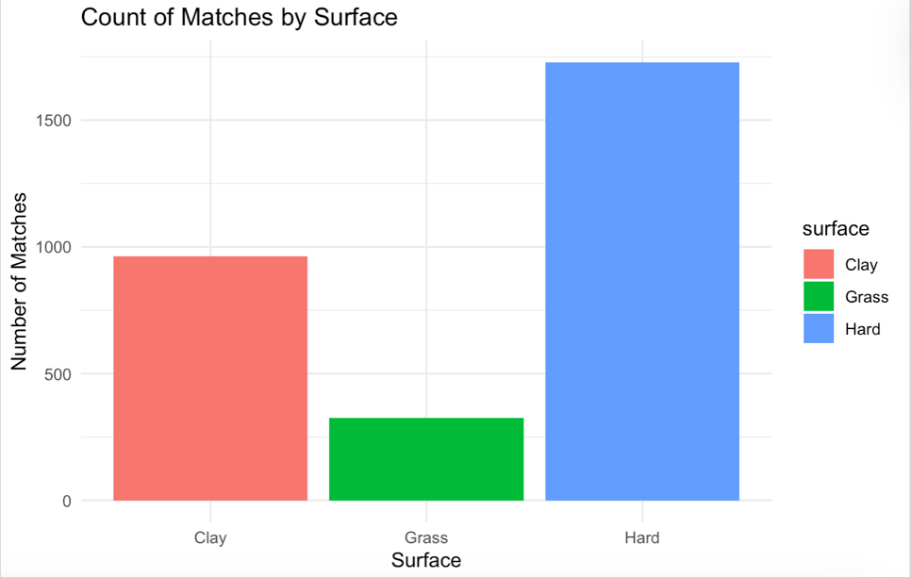
Figure 1: Number of matches across surfaces

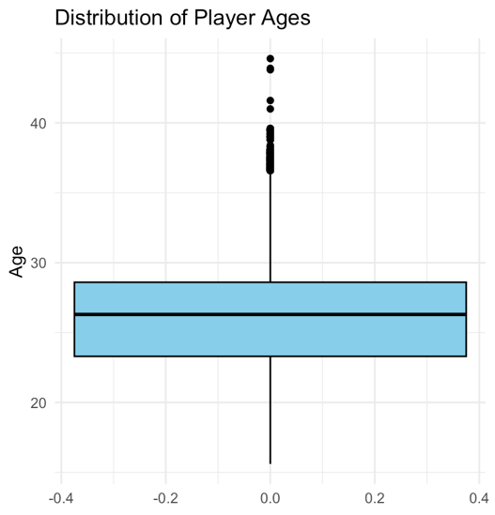
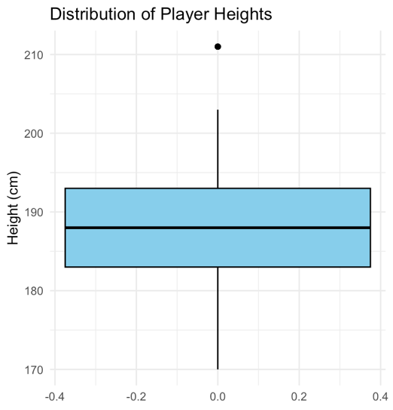
Figure 1 indicates that there are approximately 1,700 matches on hard courts, 900 on clay courts, and 300 on grass courts. Showing that hard-court matches account for over half of the dataset. This is important to note when exploring other statistics in this analysis. Before examining match statistics, player characteristics were analysed using height, country, and age.
Figure 3: Boxplot for player ages 1
Figure 2: Boxplot for player heights

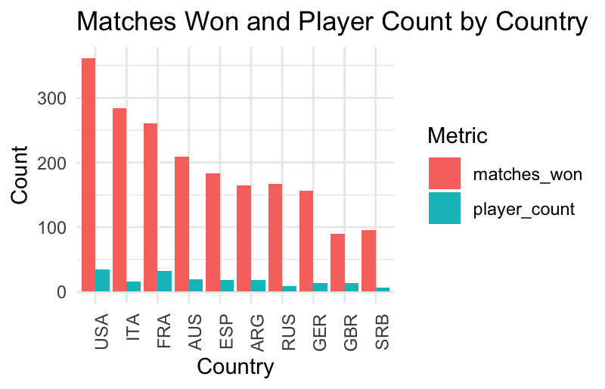
Exploring the heights of these athletes through Figure 2 reveals that they range from 211cm (Reilly Opelka) to 170 cm (Sebastian Baez and Yoshihito Nishioka), with an interquartile range of 183-193cm and a median of 188cm. Converting to feet and inches reveals that many elite tennis players are between 6 feet and 6 feet 4 inches tall. Figure 3 shows the players’ ages ranging between 18 and 42, with the IQR between 23 and 29 and the median at 26.
Figure 4: Stacked bar chart showing match wins and player count per country

Examining the countries of elite tennis players, Figure 4 displays the number of wins each country achieved in the 2024 season, as well as the number of players from that country. After building this graph, it is evident that the USA has the highest number of wins, with over 350, and the highest number of players, at 35. Italy ranks second in the number of wins, with around 275. Still, it has only 16 players, fewer than many other countries, indicating the likely dominance of Jannik Sinner and other Italian players at the top of the game. Followed by France, with over 250 wins, but 32 players, and then Australia and Spain rounding up the top 5.
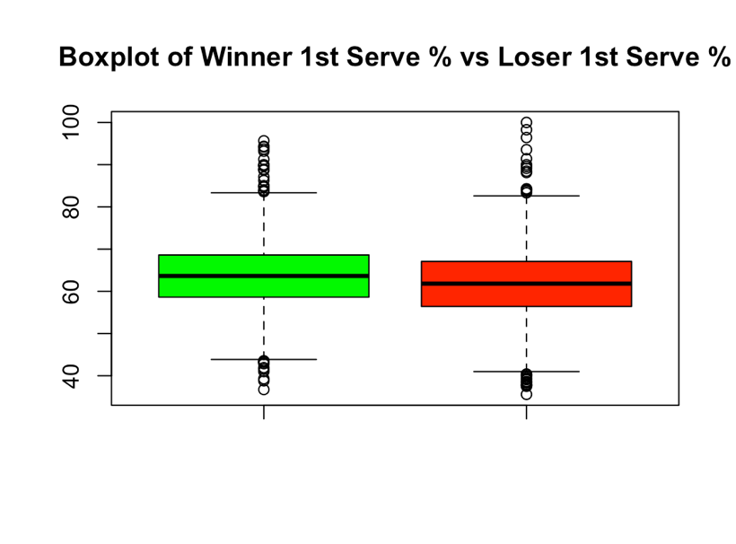
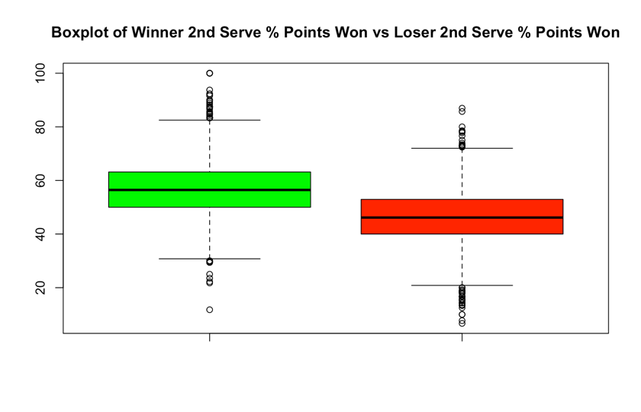
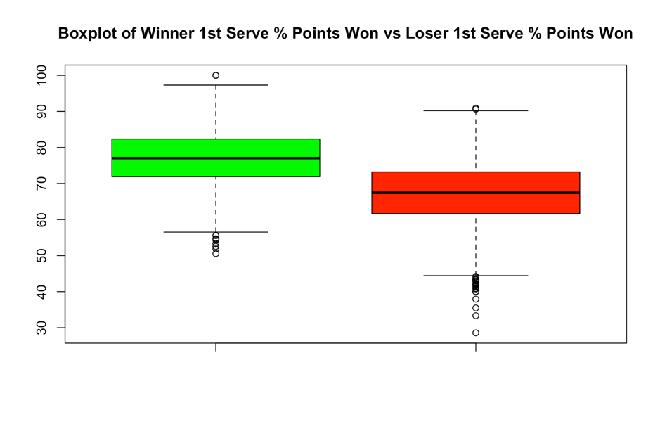
Figure 6: Boxplot of winner and loser 1st serve percentage points won
Figure 5: Boxplot of winner and loser 1st serve percentage

Figure 7: Boxplot of winner and loser 2nd serve percentage points won

Initial boxplots were examined to provide statistics for developing an understanding of their summary values; these were separated into winners (green) and losers (red) to distinguish between outcomes clearly. 1st serve percentage stats were relatively similar, with a median of 63% for winners and 61% for losers; this slight difference is down to 1st serve percentage being an aspect that the player can control, and does not have any impact from the opponent, apart from a potential psychological effect if their opponent is returning very well resulting in a player going for a bigger first serve and missing more, however this is theoretical and I have made no scientific research into this impact. The percentage of 1st and 2nd serve points won created a bigger difference between the medians of players. 1st serve results were recorded at 76% for winners and 67% for losers, resulting in a 9% difference. The 2nd serve results were recorded at 56% for winners and 46% for losers, resulting in a 10% difference. These statistics highlight the power the serve has in a tennis match, as well as how winners can find ways to exploit their opponent’s serve.
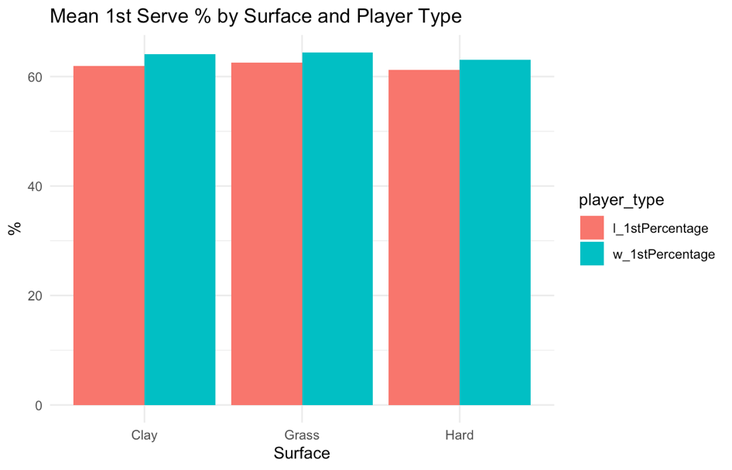
These serve statistics are based on all three surfaces combined: hard, grass, and clay. They can be broken down further to see the impact the surface has on the server’s statistics.
Figure 8: Stacked bar chart of mean 1st serve percentage by surface and player type

Figure 8 shows the 1st serve percentage for winners and losers across the three surfaces. As initially expected, there are no evident differences between the 1st % across the three surfaces. This is because the statistic is based on the serve landing in the court, meaning the surface should not affect it. Although the percentage is slightly lower on hard courts compared to grass and clay, there could be many reasons for this slight difference. From the increased number of matches played on hard courts over the year, resulting in greater variability, as players have more opportunities to record lower serve percentages. More tournaments mean more opportunities for lower-ranked players to compete, potentially lowering their percentages.
Additionally, players may become more fatigued and less rested before the tournament starts. There are also 2 Grand Slam events on hard courts, compared to 1 on each of clay and grass. As Grand Slams are played in a best-of-5-set format, this creates more matches where players are more fatigued, resulting in lower serve percentages. Players may be more willing to take risks on hard courts as they offer a more balanced speed and neutral bounce, making it easy for returners to attack. Therefore, this causes servers on a hard court to aim for better placement or 1st serves, sacrificing some 1st serve percentage. With the other surfaces, as clay is slower and not as serve-dominated, players may not feel it is as essential to take risks, as there is less reward. Additionally, on grass, the ball skids and bounces low, so players do not need to be as aggressive due to the surface doing some of the work for them; making them focus on keeping a high 1st serve percentage.
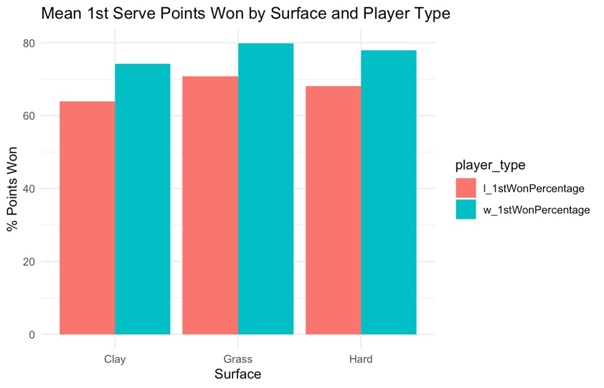
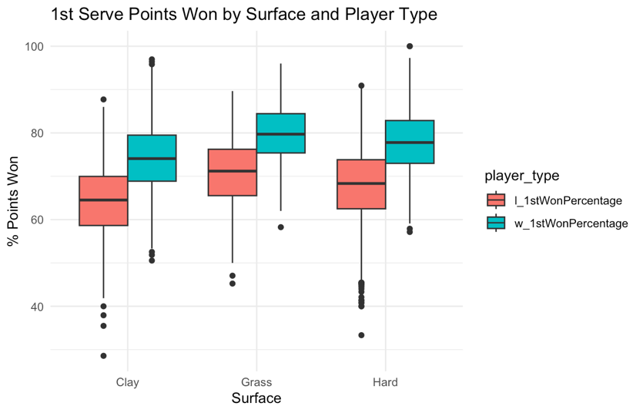

Figure 10: Stacked bar chart for mean 1st serve percentage points won by surface and player type
Figure 9: Boxplot for 1st serve points won by surface and player type

Figures 9 and 10 illustrate the impact of the surface on 1st serve percentage points won. The boxplots represent the distribution of percentage points won, while the bar chart displays the mean percentage points won. Clay demonstrated the lowest percentage of points won, with approximately 74% for winners and 63% for losers. Hard courts demonstrated success rates of 78% for winners and 68% for losers, while grass, which had the highest success rates, achieved 80% for winners and 70% for losers. These statistics highlight the differences between the two, showing that grass court tennis is the easiest to hold service points and therefore the fastest court to play on.
In contrast, clay is the hardest to hold a player’s serve, making it a more return-dominated surface and hence the slowest. Hard courts offer a medium-paced game; however, it is closer in style to grass than to clay. Each surface maintained a 10% difference between winners and losers, indicating a consistent margin by which a player must outperform their opponent.
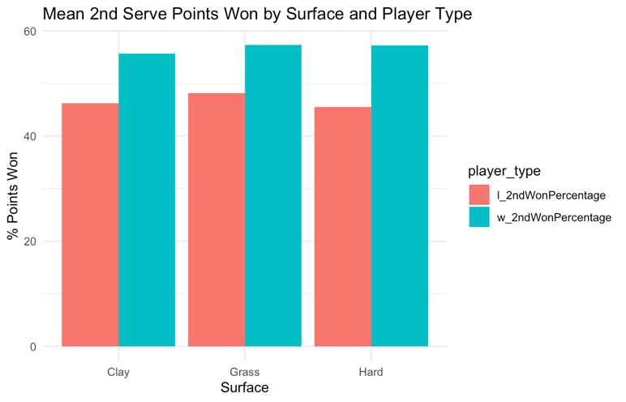
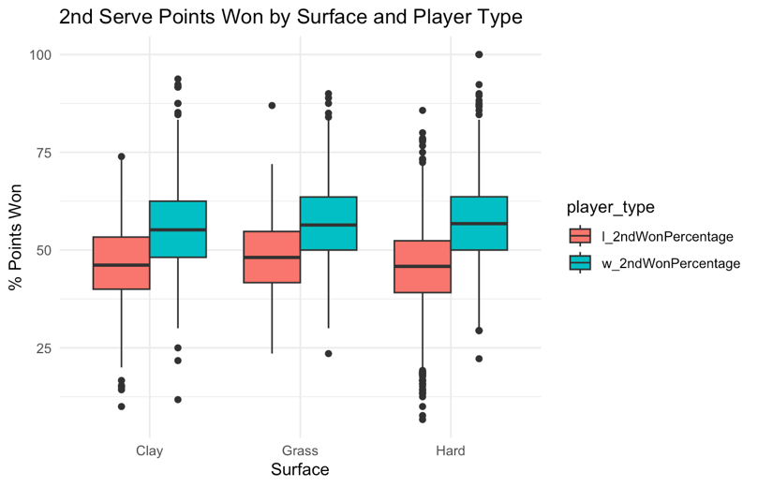
Figure 12: Stacked bar chart for mean 2nd serve percentage points won by surface and player type
Figure 11: Boxplot for 2nd serve percentage points won by surface and player type

When analysing 2nd serve percentage points won across surfaces, some differences were found in comparison to 1st serve percentage points won. Figures 11 and 12 illustrate that there are very marginal differences between how the surfaces affect this variable. There are more minor differences between the means for losers and winners on grass, as losers can win a greater percentage of points due to the low, skidding bounce and the difficulty of attacking even weak second serves. The most significant difference between the means of the winners and the losers was observed on hard courts, where there is less defensive protection compared to clay courts, due to the hard court being faster and harder to slide and move around. This makes the quality of the 2nd serve a big separator between winners and losers, as it is easier to penetrate from the return. In comparison to the 1st serve, there were significant differences between grass and clay; however, as the first serve is regarded as a weapon, the grass court amplifies it due to the low bounce. 2nd serves are safer and have more spin due to the avoidance of double faults; therefore, due to their safety nature, there are fewer differences across surfaces.

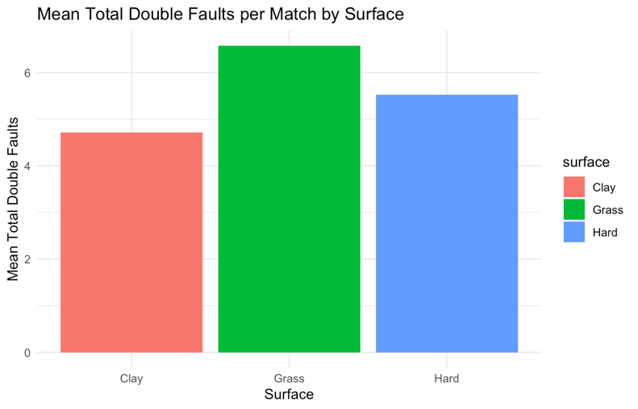
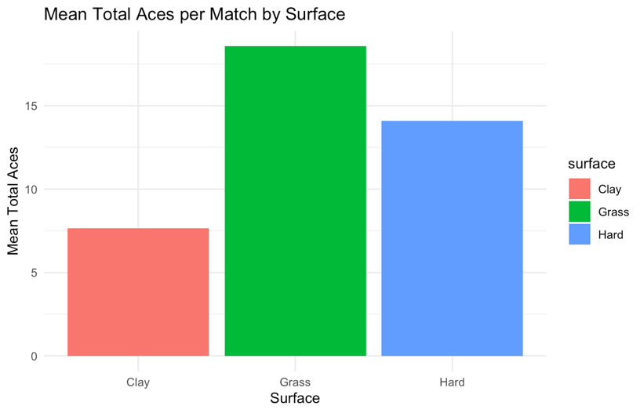
Figure 14: Bar chart for mean total double faults by surface
Figure 13: Bar chart for mean total aces by surface
Figure 13 illustrates the significant differences in the number of ‘free’ points behind a player’s serve. Clay courts show a mean of 8 aces, compared to grass with 18 and hard with 14. This highlights the difference in speed across surface types, making it easier to serve aces on grass due to the faster courts, with 10 more aces served compared to clay. This will add to the reasons why the 1st serves percentage points won are higher on grass and hard courts, as it is more common to win easy points using an ace. Again, hard courts show more similar statistics to grass than to clay, despite being classified as a medium-paced surface. One reason for this could be that, in the data, hard-court tournaments can also be played indoors, which boosts their serving statistics due to the lack of environmental conditions during an indoor event.
Figure 14 demonstrates similar results across surfaces; however, there are closer relationships in comparison to total aces. Clay showed a mean of 4.9, grass had a mean of 6.4, and hard had a mean of 5.4. More double faults will be seen on grass, as it is more rewarding to be more aggressive on the serve, resulting in more serves missed and more double faults. On less serve-dominated surfaces, it is not as essential to ensure a strong second serve; therefore, the percentage of serves made will increase, resulting in fewer double faults.
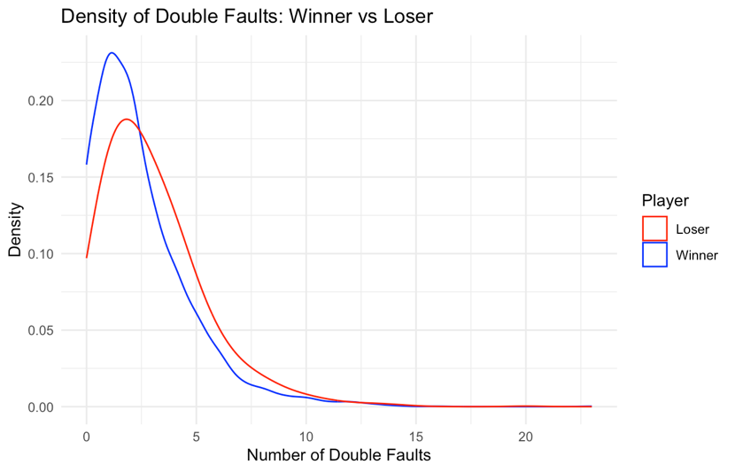
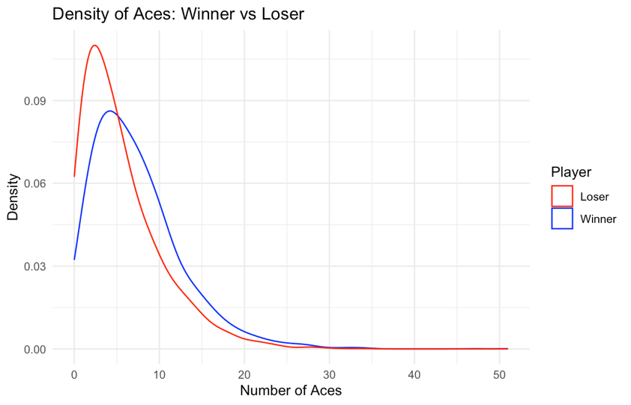
Figure 16: Density graph for winner and loser double faults
Figure 15: Density graph for winner and loser aces

Figures 15 and 16 illustrate density graphs that examine the differences between winners and losers in terms of aces and double faults. Regarding aces, the loser has a higher density for a small number of aces, with a maximum density of 2.5, compared to the winner, with a maximum density of 4; the loser's curve then sharply decreases as the number of aces increases. The winner’s curve exhibits a smaller density when there are fewer aces, but does not decrease as sharply as the loser’s curve. Examining the intersection point, the winner has a higher density than the loser when the number of aces exceeds 5.
The density graph of double faults is higher for the winner at a lower number of double faults, with a maximum of 1, compared to the loser’s maximum of 2. The winner’s curve then decreases at a fast rate, intersecting the loser’s curve at 2.5 double faults, meaning that the loser is more likely to hit more double faults as their density remains higher for greater values.
Breakpoints are crucial in tennis, as they give players the chance to win the game while their opponent is serving. They can be recorded in many ways: the number of break points converted, the break point conversion percentage, the break point chances, or from the server’s perspective: break points faced, break points saved, and the break points saved percentage. Throughout my analysis, the first three ways were considered, as many statistics contain information about a player’s serve.
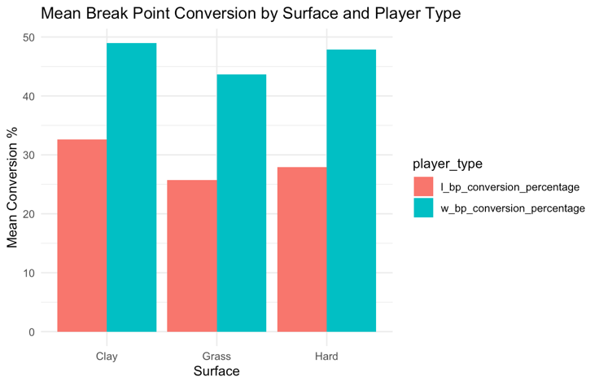
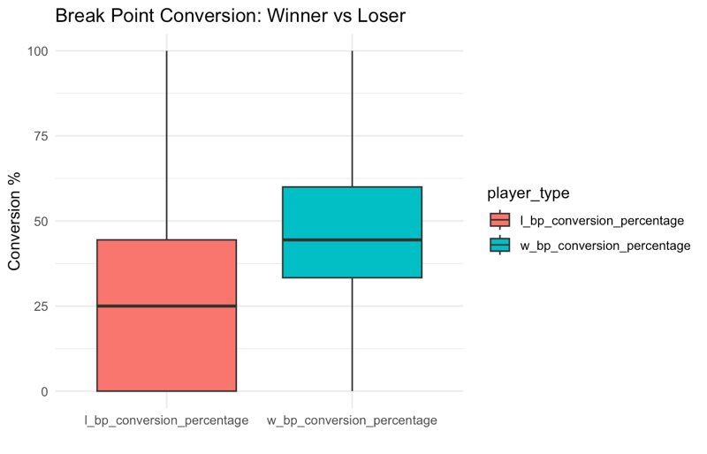
Figure 17: Boxplot for Break point conversion percentage by player type
Figure 18: Stacked bar chart of mean break point conversion percentage by surface and player type

Figure 17 demonstrates that the losers had a median of 30%. In comparison, the winners had a median of 42%, indicating that they are more clinical in their approach to their chances. The IQR ranges vary in size, with the losers having a wider range than the winners. This could be where losers have many opportunities, but they fail to capitalise on them, resulting in lower conversion percentages. Alternatively, the players could have two break points and convert one, resulting in a 50% conversion.
Figure 18 compares the conversion percentages across surfaces, with clay having the highest percentage for both winners and losers, followed by hard courts and grass courts. This consolidates earlier findings, with clay being a less serve-dominated surface. As grass is faster and more serve-dominated, it is harder to win return points, resulting in a lower percentage of break points won compared to slower surfaces, such as clay and hard. Whereas clay is slower, making it harder for the server to win these pressure points, which gives the returner a greater advantage.

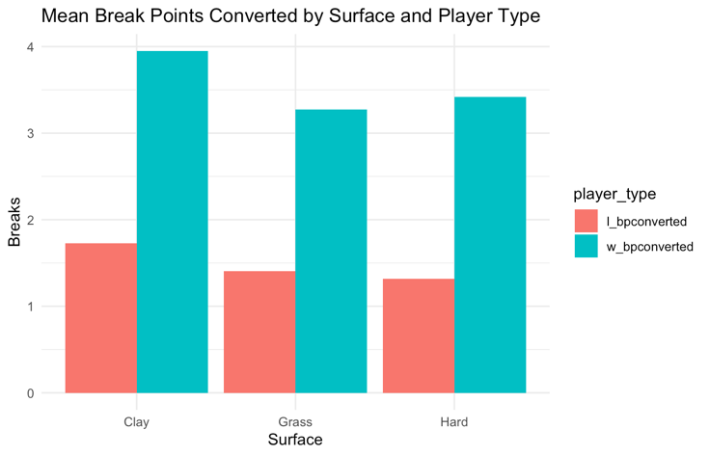
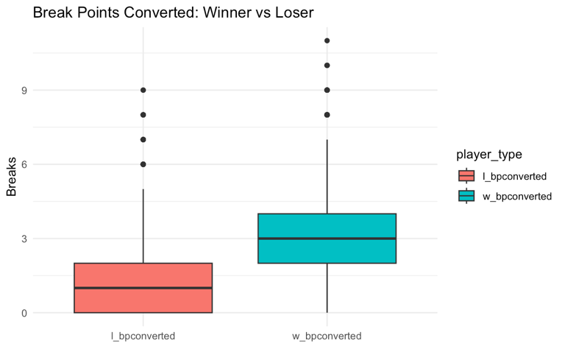
Figure 20: Stacked bar chart for mean break point converted by surface and player type
Figure 19: Boxplot for Break points converted by player type
The Breakpoint variable can be adjusted to breakpoints converted, and the frequency of breaks in each match is investigated for both winners and losers. Figure 19 shows that the IQR for losers is between 0 and 2, with the median at 1. For winners, the IQR ranges from 2 to 4, with a median of 3. To win a tennis match, a player will need to break their opponent two more times than their serve gets broken, which would correspond to a break difference in each set. To win a set, a player must win by two games, unless the score reaches 6-6, in which case a tiebreak is played. In this tiebreak, each player serves two points at a time, ensuring there are no differences in breaks within the set.
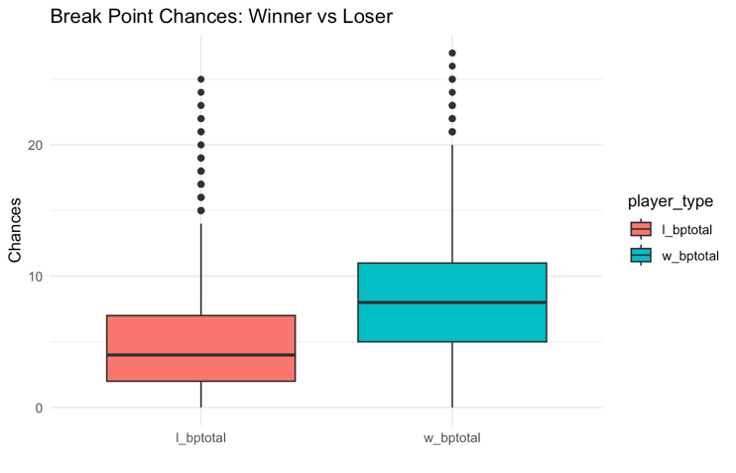
This can also be examined by surface to see if clay courts exhibit more breaks of serve per match. Figure 20 reveals little differences between Grass and Hard courts; however, clay courts have almost one more break per match when comparing winners. This could be due to fewer matches going to tiebreaks, slower courts, and fewer points won behind serve.
Figure 22: Stacked bar chart for mean breakpoint chances by surface and player type
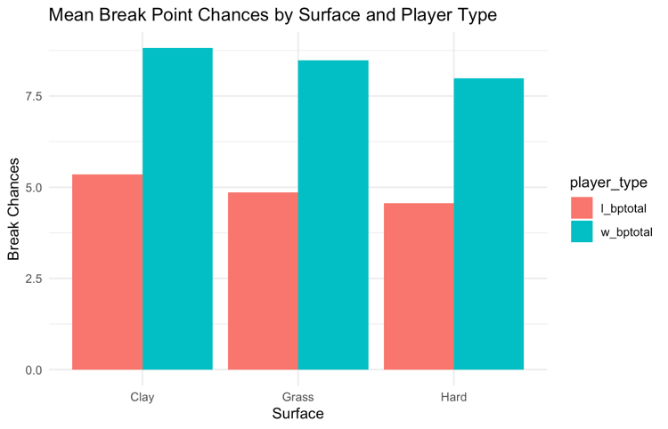
Figure 21: Boxplot for breakpoint chances by player type
Changing the breakpoint variable to breakpoint chances shows how many breakpoint opportunities both types of players are expected to see in a match. Figure 21 shows that losers are expected to see four break points, whereas winners are expected to see eight break points, twice as many as the losers. In other words, having more opportunities increases the player’s chances of winning the match.
Figure 22 compares the differences in surfaces, showing marginal variations in the number of break chances. Clay has the most break chances for both winners and losers, followed by Grass, and then Hard. Although the differences between Clay and hard are minimal, with Clay offering fewer than one extra break point for winners and losers when compared to Hard courts.
3.3 Data Modelling
3.3.1 Method
During modelling, two main approaches were employed. Match outcome models, where the binary dependent variable indicates whether the player won = 1, or lost = 0, in the match. This was modelled using logistic regression, with independent variables serving as predictors, and log odds estimates were analysed, as well as probability changes to provide an interpretable analysis for each predictor. The other approach was a Point-level performance model, where the dependent variable was the proportion of points won by a player, represented as the number of points won out of the total points played. This was modelled using a binomial model and implemented in R using the cbind function, where the dependent variable was defined as cbind (points won, points lost).
All models were initially specified with the complete set of match variables. Then, a manual stepwise reduction process was followed, removing any non-statistically significant predictors to improve AIC values and return fewer complex models. Models were also investigated, separating the break point variable into the three categories established earlier. To examine whether results differed when this variable was changed, given the considerable significance a break of serve can have on a match. Differences in variables were also calculated and included in separate models for both modelling approaches to investigate whether these differences had a greater impact than models with the player and opponent’s statistics as individual variables. Correlations between predictors and the dependent variable were analysed using Pearson correlation coefficients to ensure that variables were not highly correlated, potentially carrying similar information and making other variables redundant. This can also lead to poor interpretability, as they would measure the same aspect of performance. Additionally, variance inflation factors (VIFs) were calculated to assess the presence of multicollinearity. Variables with a VIF greater than five were considered potentially problematic, and adjustments were made to ensure that the final model did not include variables with high VIF scores.
For logistic regression models, model accuracy was evaluated using AIC, likelihood ratios, and analysis of deviance, and classification accuracy was evaluated using cross-validation. For binomial models, model accuracy was assessed using AIC, pseudo-R-squared, marginal change, root mean squared error (RMSE), and mean absolute error (MAE) via bootstrap resampling.
A seed was set before producing the updated ATP dataset to ensure the same results are achieved each time the dataset is run. This updated dataset is prepared and structured for suitable modelling. Matches were reformatted so that each observation represented a comparison between player 1 and player 2 for a binary outcome model. This indicated whether the focal player (player1) won the match. To avoid systematic bias, a random flip was introduced, ensuring that the winner was not always coded as player 1. This ensured a balanced dataset, with half the winners recorded as Player 1 and half as Player 2. For each match, variables were extracted for both players, including all dependent variables. In addition, differences in variables were calculated and added to the dataset, allowing for the modelling of relative performance, which could lead to more detailed analyses than absolute statistics. To ensure data quality, matches without recorded rankings and matches of short duration (< 43 minutes) due to retirements were removed. This filtered out incomplete matches that could have led to more biased results.
3.3.2 Results
Firstly, I ensured the flip gave an equal set of wins and losses. Initially, there were three more losses than wins. To balance this out, the losses were removed by setting the minimum value for both outcomes. The match date was converted to a number, starting from the first day of the year, to investigate any changes throughout the year. When fitting the first model, all variables were included. The package ‘car’ was installed to check for multicollinearity using VIF. This result showed that all breakpoints converted variables had a VIF score above five, which was expected, as they represent the same statistic in different ways. Correlation coefficients can also be recorded, comparing them with other independent variables and the dependent variable. Moderately high correlations were observed between breakpoint variables, so these were examined in separate models. It is also important to note that the correlation between the outcome and the breakpoints converted is 0.58, indicating a high positive correlation. This could be due to the tennis scoring system, as breaks are needed to win matches, unless sets end with tiebreaks. This could lead to them revealing too much information and hiding other insights from variables.
Investigating further, focusing on the breakpoints converted. Upon checking the VIF for this model, a lower value was found for the breakpoint’s variable; however, caution must be applied due to the score of four. From the base model, player 1's rank is significant; however, player 2’s rank is not. This suggests that the player's rank is an important factor for the model to predict the outcome accurately. This variable can be changed to a ranking difference to see if it affected the model's output. No statistical improvements were made, so player1’s rank was included as the ranking variable. Moving through the stepwise reduction process, the variables: surface, duration, match date number, aces, and opponent double faults were removed. Throughout this process, quadratic and cubic terms were added for duration and match date number to see if any trends happened throughout the season; however, no evidence of this was found. The surface baseline was set initially to Clay due to alphabetical order. This was changed to both 'Grass' and 'Hard'; however, no improvement was made to the model. The final model, presented in Table 1 below, illustrates the impact of each variable on the match outcome.

Table 1: Final Model for breakpoint converted
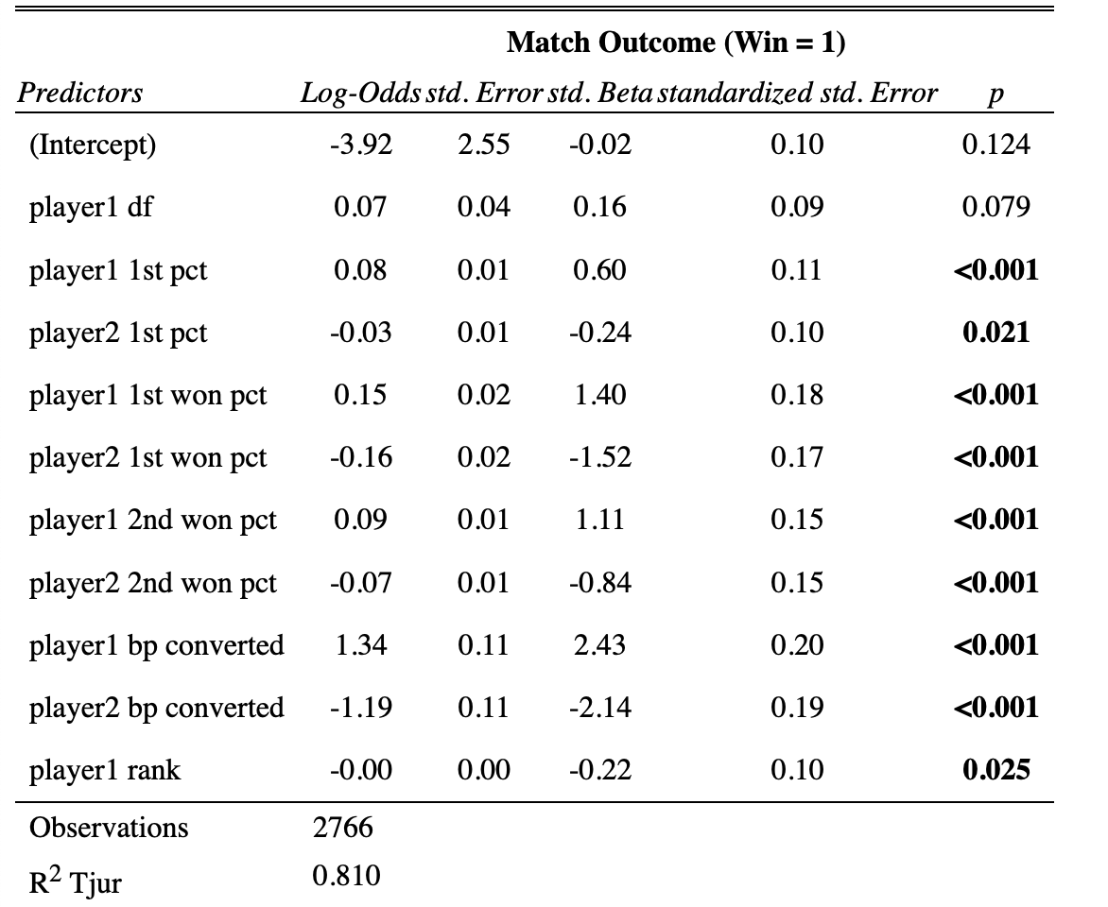

The same stepwise reduction process can be applied to calculate the break point conversion percentage as the breakpoint variable. All variables were initially considered to investigate any differences between models with breakpoints converted. The final model for breakpoint conversion percentage included the same variables; however, the statistical significance of these variables differed slightly. The final model results are included in Table 2 below.

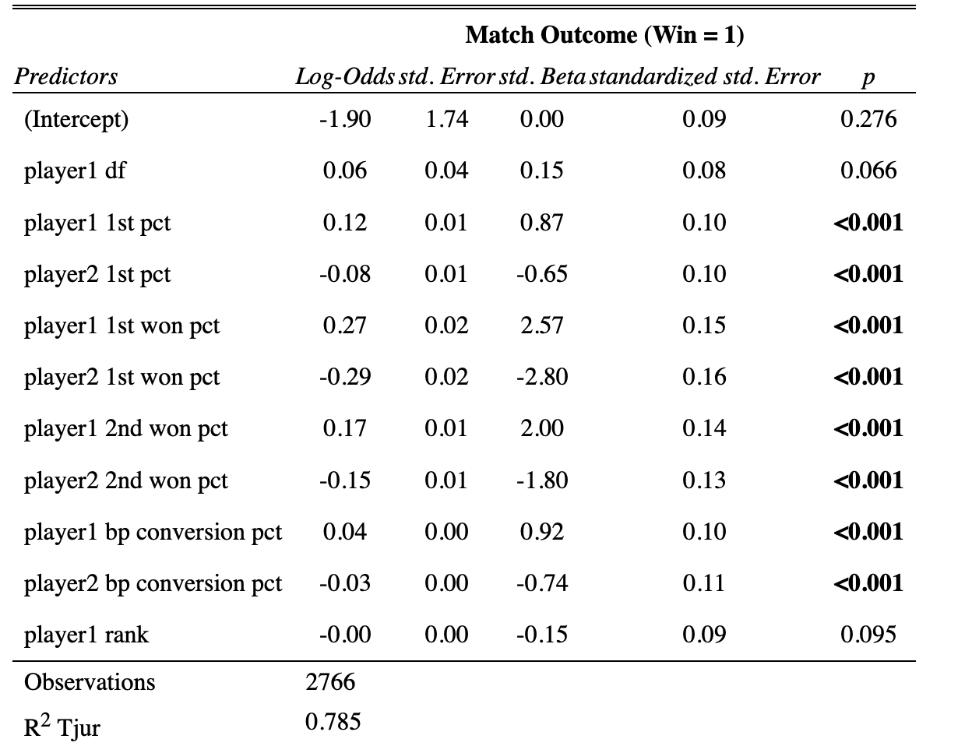
Table 2: Final model for breakpoint conversion percentage

Player 2’s 1st serve percentage became significant to the 3-star level compared to the 1-star shown with break points converted. Additionally, player 1’s ranking became marginally significant, with a p-value of 0.09 instead of 0.02. This variable remained in the model as it slightly improved the AIC and residual deviance. When comparing models, a difference in AIC values was observed, with the breakpoints converted model having a lower AIC value by 100 units. Upon closer examination of the estimates for each variable, it becomes apparent that the model demonstrates a more balanced set of estimates for the breakpoint conversion percentage. This is due to the difference in scales between the variables. Breakpoints conversion percentage is on a scale of 0-100, so a 1-unit change will reflect a percentage point, hence not changing the number of breaks in the match. Breakpoints converted can range from 0 to 10. This means a 1-unit change is equivalent to an extra break in the match, representing a significant change in the outcome and therefore showing large estimate coefficients. Other variables within the breakpoints conversion percentage model had a greater impact on the outcome compared to the breakpoints converted model, as breakpoints converted made other variables less impactful, as it can explain the match without as much need for serve statistics. Additionally, breakpoints converted had a higher correlation coefficient with the outcome, indicating that this variable may overshadow the effects of other variables.
Next, breakpoint chances were examined using the same process. Here, differences to the final model were expected due to the number of chances not explicitly stating if the player managed to convert them. The final model included extra variables of opponent aces and surface. Due to the surface being statistically significant, different models were created using different baselines to see the changes in the surface. When the baseline was set to Clay, the results showed the most information; this could be due to Clay being the slowest surface, so larger differences were found as service percentage points won became the most crucial variable. As the estimates are in a log odds scale, calculating the exponential gives the change in odds across surfaces. Grass courts showed a value of 1.92, indicating that the odds of winning are almost double compared to clay, holding other factors constant. Hard courts showed a value of 1.46, indicating that the odds of winning are approximately 46% higher compared to clay, while holding other factors constant.
Table 3 below illustrates the final model summary from the breakpoint chances variable.
Table 3: Final model for breakpoint chances
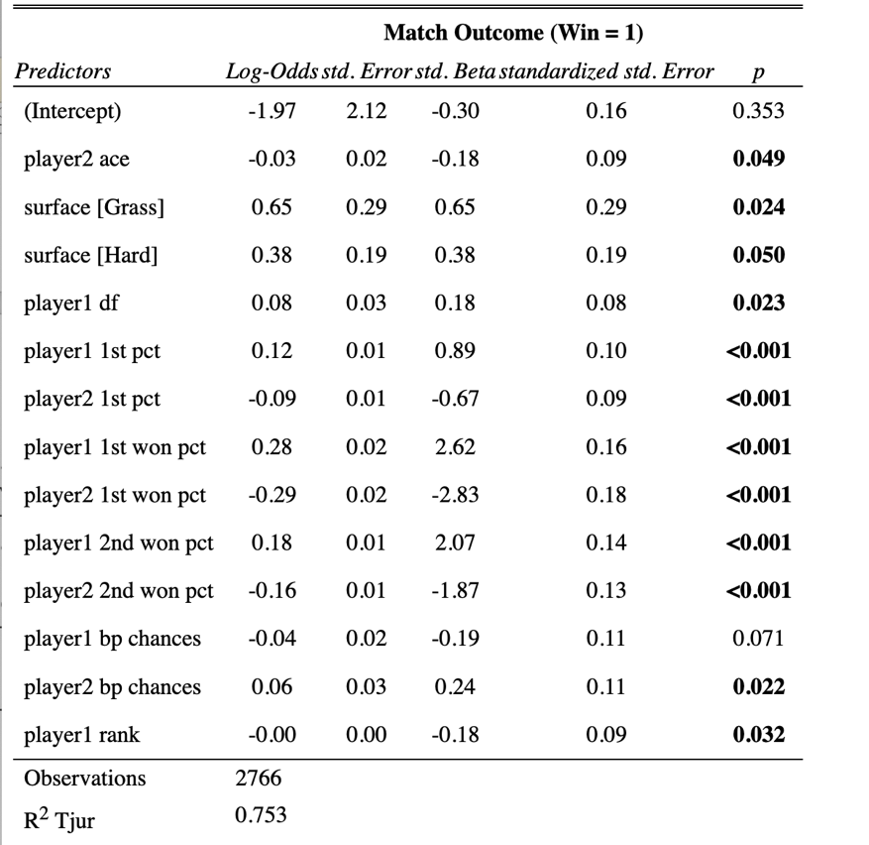

The breakpoint chances variable lost statistical significance, with p-values of 0.07 and 0.02 for player 1 and player 2, respectively. This meant the AIC value increased because the breakpoint variable did not dominate findings. Interestingly, when the signs were examined for each variable’s estimate, differences were observed in the data analysis results. The expectation would be that Player 1’s estimates are all positive, as an increase in a variable would improve the outcome of winning the match, and Player 2’s estimates are all negative, as higher match statistics would decrease the chance of Player 1 winning the match. Apart from Player 1’s rank, the lower the number, the better the player is in the world, and Player 1 double faults, as this means they missed both serves, therefore losing the point. Hence, negative values are expected for these variables.
Player 1's double faults showed a positive sign, suggesting that more double faults increase the chance the player had of winning the match. This is also true for player 1's breakpoint chances being negative, meaning that more break point chances resulted in the player having a lower chance of winning the match, and vice versa for player 2. It is essential to see that the estimates are minimal, and the p-values show minor statistical significance. Additionally, this estimate is calculated under the assumption that all other variables are constant. The model already incorporates the percentage of points won on 1st and 2nd serves, which explains the detrimental effects of double faults and the issue with break points. Left over is the signal that players who are generally strong servers sometimes double-fault more often, or players who have high break point chances but a low conversion percentage. This is known as a suppressor effect, as these variables may not exhibit these signs when considered individually. Still, in the presence of correlated variables, the regression uses them to improve model fit, causing a sign flip. This can be confirmed with a model that only simulates player double faults and breakpoint chances.
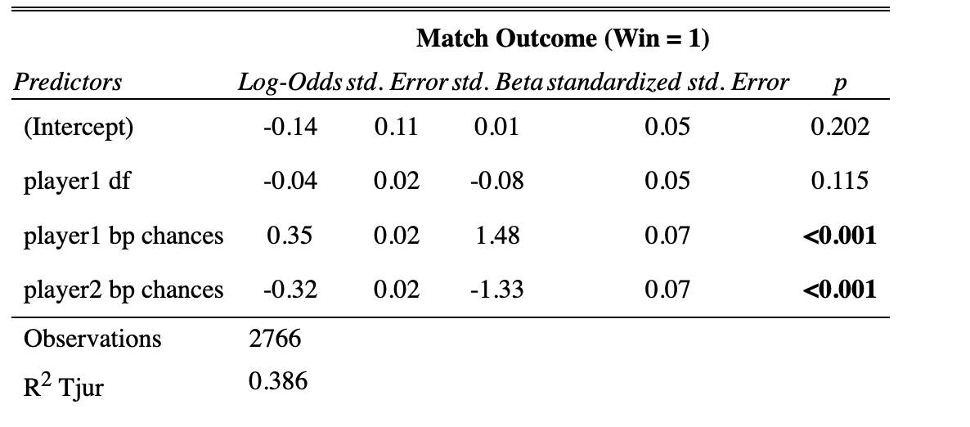
Table 4: Model with only breakpoint chances and player double faults

Table 4 shows that the original interpretation of these variables was correct, as the signs now flipped to what would have been initially expected, confirming that they are suppressor variables.
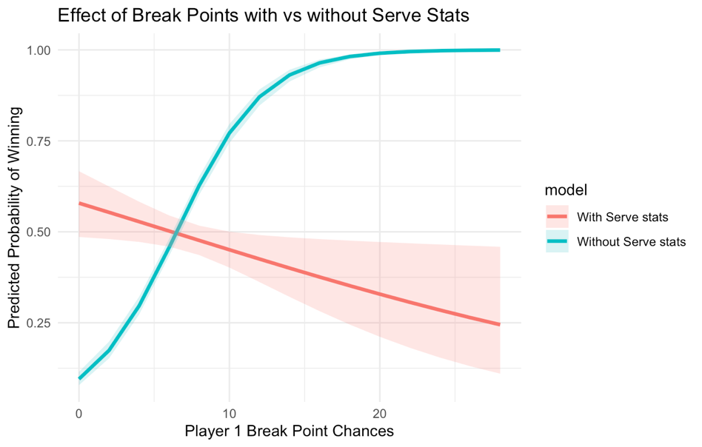
Marginal effects graphs were used to examine the effect of variables on the outcome between the model with and without serving statistics. The package “ggeffects” was imported to give this information. Figure 23 provided a clear image of how the variable was affected within each model.
Figure 23: Marginal effects graph for player 1 breakpoint chances with serve and without serve statistics

Without serving statistics, an increasing curve was shown for more breakpoint chances, with a probability of winning within small confidence intervals. Whereas the model with serving statistics showed a decreasing line, large confidence intervals were also present, indicating that the variance is high and the model is less sure about the predictor’s effect.
Variable Importance can be calculated to determine which variables contributed the most to predicting the outcome. The package ‘caret’ was imported to show this information. The most critical factors for the final model with breakpoint chances were the percentage of points won on the 1st and 2nd serves for both players. Followed by the player’s 1st serve percentage as moderately important, and less important features such as surface, aces, double faults, and break point chances. These results changed between the final models with different breakpoint variables. When breakpoints converted were considered, they were the most important features, followed by the 1st serve percentage points won for both players, and then the 2nd serve percentage points won for both players, and player 1’s 1st serve percentage. For the breakpoint conversion percentage, the points won behind serve become the most important features, followed by the conversion percentage and 1st serve percentage. Illustrating similar results to the model with breakpoint chances.
Table 5: Variable Importance for all final models
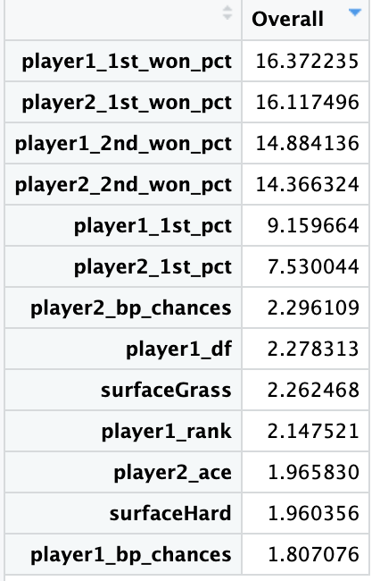
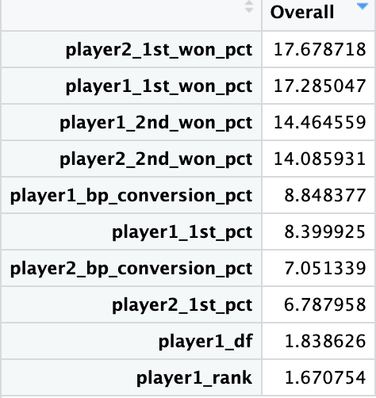
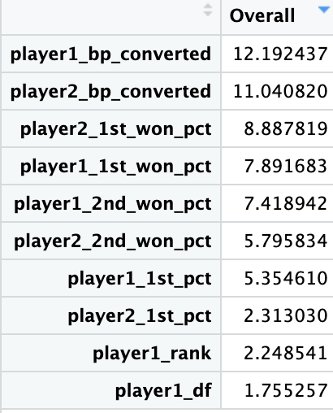

The exact process for choosing variables can be applied to the variables that measure the difference between opponents. For breakpoints converted and conversion percentage, the same variables were included in the final models: the 1st serve percentage difference, the difference in 1st and 2nd serve percentage won, the breakpoint variable difference, and player 1's ranking. Comparing the models with their respective absolute variable final models revealed weaker AIC values for the difference variable models, indicating that these did not improve the model fit. For the breakpoint chances difference final model, the aces difference was also included due to its statistical significance. This added the difference in free points won from a server, which was previously hidden when considering other breakpoint variables. The AIC values for this model were very similar to those of its model with separate player variables.
A function was created to interpret the effect each variable has on the outcome of the match. Due to the estimates being log odds changes, this was adjusted to show the percentage difference that a 1-unit change in the variable had on the outcome, making it more interpretable and generalisable. The function took the baseline profile, which included means for numeric variables. When calling this function, any model can be analysed to show the number of units of change. Table 6 below demonstrates the probability changes for each of the final models with separate variables for each player. A 1-unit change was established for every table.

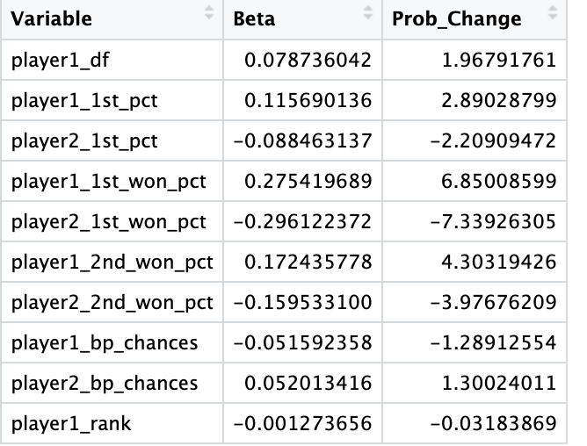
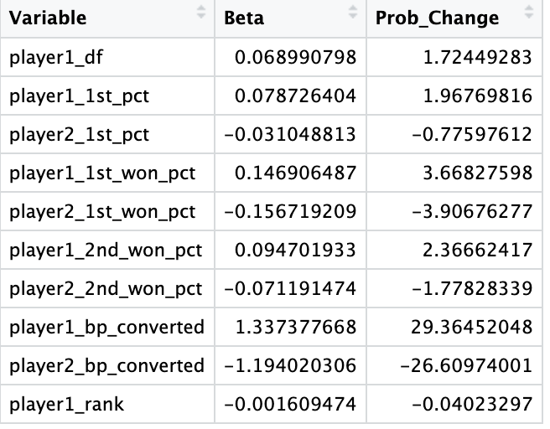
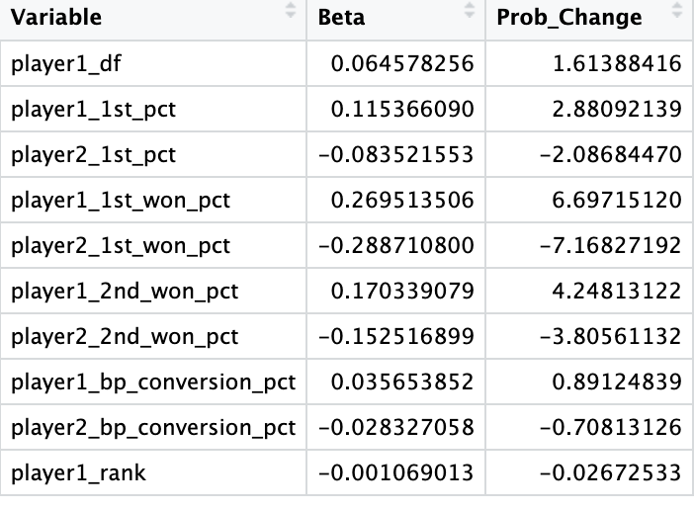
Table 6: Probability percentage change for 1 unit for each final model
The surface was removed from the final model of breakpoint chances because it was a factor, making it difficult to compare how probabilities changed. As the surface was removed, player 2’s aces became not statistically significant, so that variable was also removed for this analysis. This meant all models had the same variables around the breakpoint variable used, allowing straightforward interpretation.
According to the breakpoints converted table, an extra break can lead to a 29% increase in winning; however, since achieving a break requires multiple factors, this statistic will not be the primary focus. Comparing player 1’s 1st serve percentage points won across models shows that a 1% increase in this variable results in a 3.6% increase in the probability of the outcome for the breakpoints converted model. For both the breakpoint conversion percentage and breakpoint chances, a 6.7% probability change was shown. This highlights how a minimal increase can impact performance when not considering the frequency of breaks for both players. This also highlights how the 1st serve percentage points won is an essential feature when predicting outcomes, and players and coaches should focus on being effective from the 1st serve.
Cross-validation ROC curves can be calculated for every final model to assess how well the model predicts the outcome on unseen data across 10 folds. This separates the data into 10 partitions, using 9 for the training set and 1 for the test set. It repeats this process 10 times, changing the test set each time, resulting in an average ROC across the 10 folds.
The ROC values are high across all models with:
Breakpoints converted – 0.984
Breakpoints conversion percentage – 0.980
Breakpoints chances – 0.974

Even with the model’s prediction of breakpoint chances and breakpoint conversion percentage, a very high prediction result is achieved, indicating that the model is highly effective at identifying patterns within the data and making accurate predictions. The models using the difference between variables showed the same results, regardless of which breakpoint variable was used. This was expected due to the similar AIC values recorded earlier across models.
The very high ROC values are due to the predictors being very tightly linked to the outcome. It is essential to understand that these predictors are post-outcome, so the model may have just learned the data perfectly, even when using cross-validation. This will likely artificially inflate performance; however, the goal was to find the most critical features during a tennis match. A predictive outcome section will be included at the end of this project to assess whether pre-match statistics can accurately predict outcomes.
The next approach was to investigate the binomial model of the proportion of points won. To allow further analysis of these models, the cbind format was equal to a points matrix. The same process can be followed when creating these models. VIF scores and correlation coefficients were measured, showing low multicollinearity scores and some moderate correlation scores. As this measure is based on points won, breakpoint chances showed the highest positive correlation, as more chances equate to more opportunities to win points. This correlation was also observed with aces, which directly translates to a point won. The serve percentage points won were not as correlated with points won, as they represent a percentage of different service points, which does not directly indicate that a point has been won.
When using a stepwise reduction process for variables, all the final models for different breakpoint variables and the models including the difference between variables had the same selection. This selection included 1st serve percentage, 1st and 2nd serve percentage points won, and the breakpoint variable. The AIC values were substantial for all these models. With every model showing values above 15000, slight differences were measured across the models. In comparison to the null model, the AIC value was above 20000, indicating that the models calculated have some meaning. The reason that the AIC values were so high is that the model measured the proportion of points won. Since tennis matches involve hundreds of points, and log-likelihood is computed across all points played, the dataset will include many thousands of trials. Models with an AIC difference greater than 10 suggest strong evidence that one model is superior. After comparing all models, the model with the best AIC value was the difference model with the breakpoint conversion percentage. This gave an AIC value of 15308. The model had such small estimates that a table would not provide any meaningful data.
The package ‘pscl’ was imported to provide more meaningful statistics that help AIC demonstrate the model's strength. Llh and llhNull show the log-likelihood of the fitted model and the null model (intercept-only). The difference illustrated how much better the predictors were at explaining the data compared to the average guess. The G-squared statistic represents the likelihood ratio; since it is substantial, the model significantly outperforms the null model. The pseudo-R-squared value of 0.245 indicated that the predictors account for a significant portion of the variation in point outcomes. Finally, the R²ML (McKelvey & Zavoina’s R²) is considered the closest analogue to linear regression in logistic models. The value of 0.83 explains 83% of the latent variance in the underlying probability of winning points. This matches intuition that serve percentage points won, and breakpoints are highly predictive in tennis.
A marginal change function was created to investigate the probability change that each variable had on the outcome of winning a point. The function was called depending on the model being examined, and the delta can be adjusted to view a 1-unit difference or more. A 10-unit change was selected because this effectively measures differences. Table 7 showed the marginal change for the best model, which measured the differences from the mean.
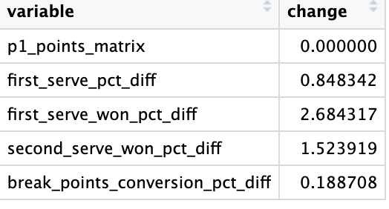
Table 7: Marginal change for the final model with breakpoints conversion percentage differences

All these percentage changes show very minor values because the model focuses on the proportion of points won. These values represent the increase in the outcome of winning an individual point, which differs significantly from the model's investigation of the overall outcome.
Functions were also created to analyse RMSE and MAE for the final model. Measuring the root mean square error shows the average squared deviation, while the mean absolute error shows the average absolute deviation. The package ‘boot’ was installed to perform bootstrapping. This is a resampling technique that randomly resamples the dataset with replacement, allowing for the examination of new datasets using the current data to assess the variability of the results. The results show an RMSE of 0.01 on the original data, indicating that the model predicted the proportion of points won almost perfectly on the same data it was trained on. The average RMSE across 100 bootstrap resamples showed a much higher value of 0.08, because it is now predicting on out-of-sample data, therefore, a more realistic performance.
The MAE value remained constant between training and bootstrapping, at 0.009. This suggested that the model’s absolute deviation from accurate proportions remained very small, even under resampling, indicating that the model remains consistently close. Confidence intervals were calculated, indicating small intervals, resulting in high confidence in the predictions. Overall, the RMSE penalises rare but significant mistakes, and the MAE demonstrates that the model remains remarkably accurate.
3.4 Regularisation
3.4.1 Method
To account for multicollinearity and to perform variable selection, regularisation techniques were applied using both LASSO (L1 penalty) and Ridge regression (L2 penalty). LASSO applies L1 regularisation, shrinking some coefficients exactly to zero, performing variable selection. Ridge regression applies L2 regularisation, which shrinks coefficients towards zero without eliminating the predictors. The ‘glmnet’ package was installed for model fitting, and coefficients were extracted for interpretation. All continuous predictors were standardised to have a zero mean and unit variance to ensure comparability and proper regularisation. Model matrices were constructed to include an intercept automatically. The optimal regularisation parameter λ for each model was selected via 10-fold cross-validation, minimizing binomial deviance. The variable importance was visualised using bar plots of absolute LASSO coefficients.

3.4.2 Results
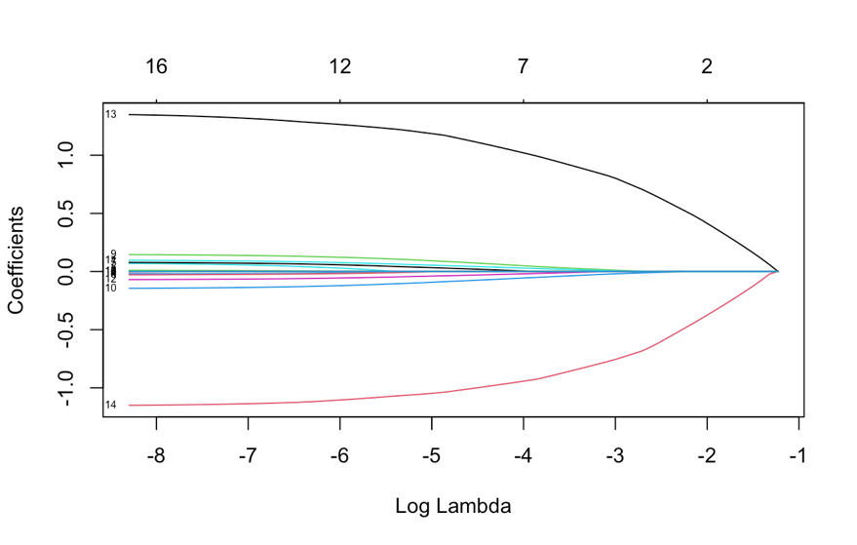
When computing LASSO regression for all variables, with breakpoints converted, the earlier selection of variables can be confirmed, as LASSO penalises unimportant variables and sends them to zero. It can be observed that the match date number, opponent double faults, and opponent rank are set to zero. Additionally, other variables are minimal, indicating very little importance; these include duration, the number of aces by the player, and the player's rank.

Figure 24: Lasso coefficients for the breakpoints converted model

Figure 24 illustrates the disparity between the coefficients of variables, as breakpoints converted express a much larger coefficient; this was scaled to minimize this difference. Ridge regression results also showed similar findings. When scaling the chosen variables, a more pronounced disparity emerges; the breakpoints converted remain dominant, but it is now clear that the following essential variables are also 1st serve percentage points won, followed by 2nd serve percentage points won. Ridge regression also showed this difference once scaled; however, the differences between variable coefficients are much more minor. This is because LASSO can force some coefficients to become very large as harsher penalties are applied to set variables to zero. Whereas Ridge applies a different penalty, shrinking coefficients toward zero evenly, this prevents any single coefficient from becoming too large.
Figures 25,26 and 27 represent the variable importance by lasso coefficients for the final models calculates using regularisation techniques.
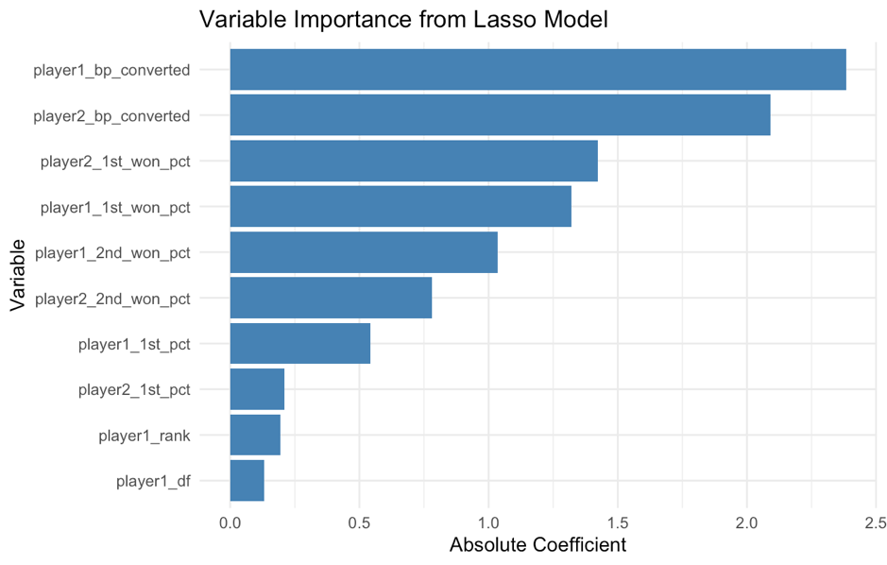

Figure 25: Variable importance for breakpoint converted scaled Lasso model
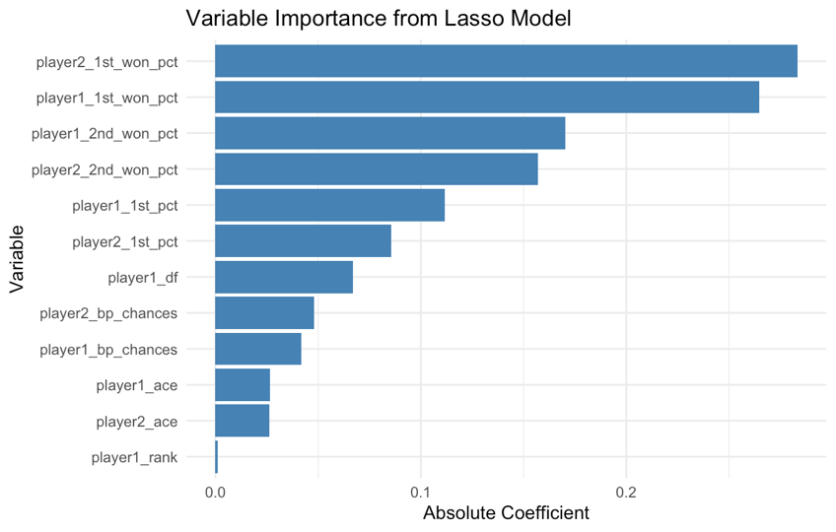

Figure 26: Variable Importance for breakpoint chances Lasso model
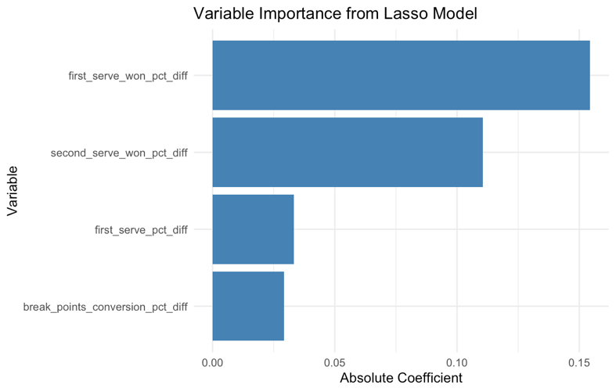

Figure 27: Variable importance for proportion points won model with scaled break points conversion percentage difference using Lasso

The exact process can be achieved for the final model using breakpoint chances, and the final model for the binomial points model with the breakpoint conversion percentage difference. With breakpoint chances, a more balanced set of coefficients was observed from LASSO and ridge before scaling. This confirms the finding that breakpoint chances are not a defining variable, as service points have now become the most important. Due to the minor differences between the coefficients and the lack of a dominant variable, the scaling did not benefit the variables. For the binomial points model, the breakpoint conversion percentage dominated the magnitude of coefficients, essentially showing the difference in a player’s ability to convert a point that wins a return game. After scaling was introduced, the variables exhibited a more balanced distribution, with the 1st serve percentage points difference emerging as the most significant variable, followed by the percentage of points won in the 2nd serve. These findings can be clearly represented in Figure 27, which illustrates the importance of each variable within its model, as indicated by the LASSO absolute coefficients.
3.5 Generalised Additive Models
3.5.1 Method
To allow for potential nonlinear effects of match statistics on player outcomes and the proportion of points won, Generalised Additive Models (GAMs) were examined using the package ‘mgcv’. These models incorporate smooth functions for predictors, enabling the model to capture curved or nonlinear associations while retaining the interpretability of generalised linear models. Smooth terms were applied for all continuous predictors to identify any possible non-linear relationships, using a binomial logit link function. Estimated degrees of freedom (EDF) were calculated and used to determine if a variable had a linear or flexible curve. Values of 1 indicated linear relationships, leaving those variables without a smoothing function. In contrast, values greater than 1 meant a smoothing function was added to investigate complexity. The use of GAMs examined if diminishing returns were a possibility for variables, and these models were assessed with graphs, likelihood ratios, AIC comparisons, and analysis of deviance.

3.5.2 Results
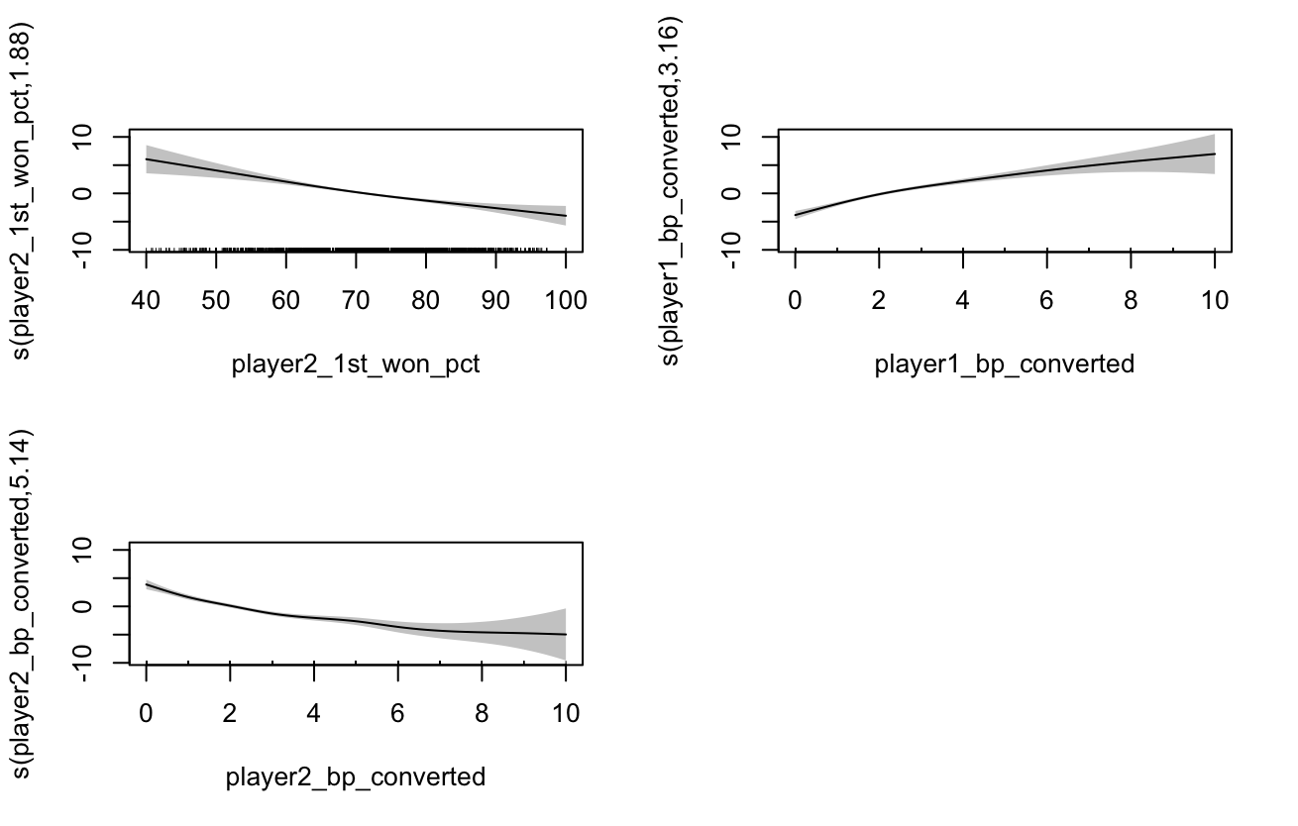
All variables were initially considered in the breakpoints converted model to see if they exhibited any non-linear relationships. Interestingly, the breakpoints converted showed high EDF values of 3 for player 1, and 5 for player 2, showing heavy curvature. Also, player 2’s 1st serve won percentage had an EDF value of 1.9, showing potential curvature. All other variables had EDF values of 1. The model was then recalculated using only smoothing functions for the variables that exhibited an EDF value greater than 1. Some differences were made from the earlier GLM model, as player 1’s double faults showed a higher p-value close to 0.1, and player 1’s rank p-value improved, making it more statistically significant. Using these smoothing splines, the R-squared value was 0.81, and 78% of the deviance was explained. Comparisons can also be made to the original GLM, as this new GAM model lowered the AIC value by 20, and the analysis of deviance table showed a 3-star statistical significance compared to its previous GLM model. Figure 28 shows the curvatures of each variable within the model.
Figure 28: Non-linear relationships for variables in the final model of breakpoints converted
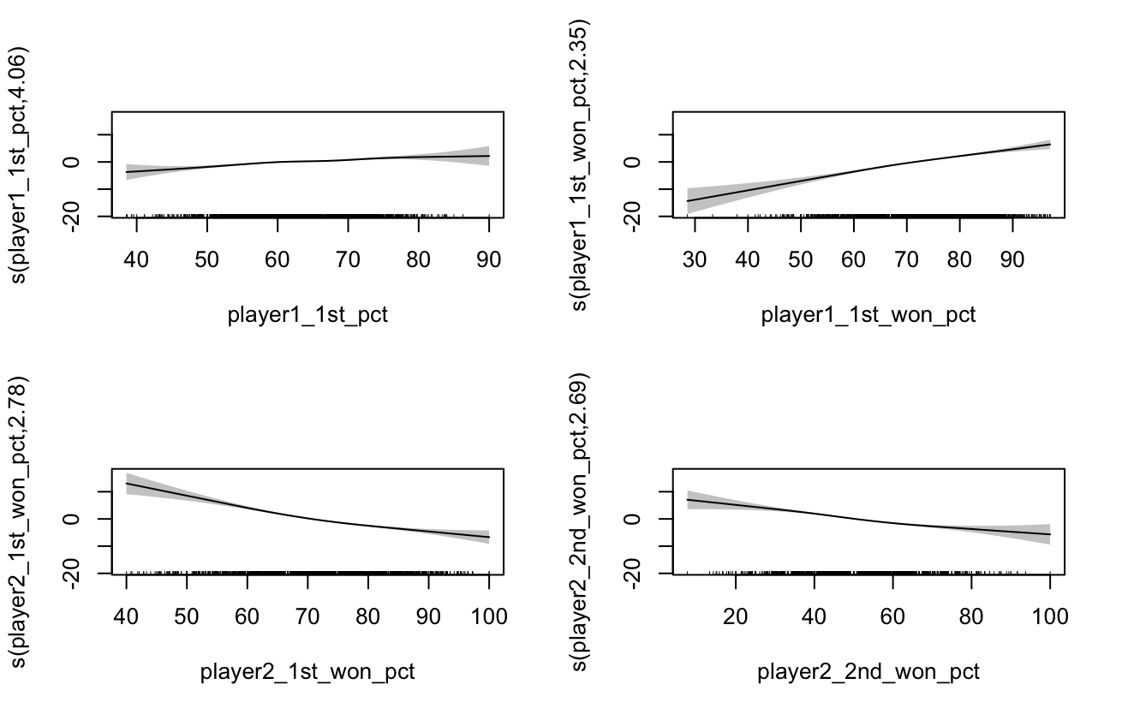
This was examined for breakpoint chances to see if variables had non-linear relationships when a different breakpoint variable was modelled. This revealed significant differences from the model discussed above, as more variables showed signs of non-linear relationships. After analysing EDF values and statistical significance for variables with and without smoothing splines, since variables with an EDF close to one could indicate more important relationships, whether linear or non-linear. The variables with a smoothing spline included player 1’s 1st serve percentage, both players’ 1st serve points won percentage, player 2’s 2nd serve won percentage, and player 2’s breakpoint chances. This resulted in an R-squared of 0.76 and 72% of deviance explained, along with an AIC value that improved the previous GLM by 24 units. When examining the k-index value of the smoothing terms, player 2’s breakpoint chances had a value of 0.6, indicating it was not well estimated. With an EDF of 1.4, the variable exhibits near-linear behaviour. Converting it back to a linear form removes complexity, which improves its p-value. Figure 29 illustrates the curvature for the variables in this model.
Figure 29: Non-linear relationships for variables in the final model of breakpoint chances

The final model for the binomial proportion of points, with the difference between players and break points conversion percentage, showed that every variable had an EDF value of 1, indicating a linear relationship. So, adding smoothing functions to this model is not beneficial and can be left as a generalised linear model.
3.6 Bayesian Modelling
3.6.1 Method
Bayesian regression models were fitted to estimate the probability of match outcomes while explicitly incorporating prior information. The models used the ‘brms’ package, which fitted models via Hamiltonian Monte Carlo sampling. All models were run with four chains and 2000 iterations per chain, to ensure adequate convergence. Model fit was assessed using leave-one-out cross-validation (LOO-CV). This provided the expected log predictive density for new data and the effective number of parameters. Comparison across models was also investigated.
Graphical posterior checks were conducted to assess model adequacy, including trace plots, posterior density plots, and LOO diagnostic plots.
3.6.2 Results
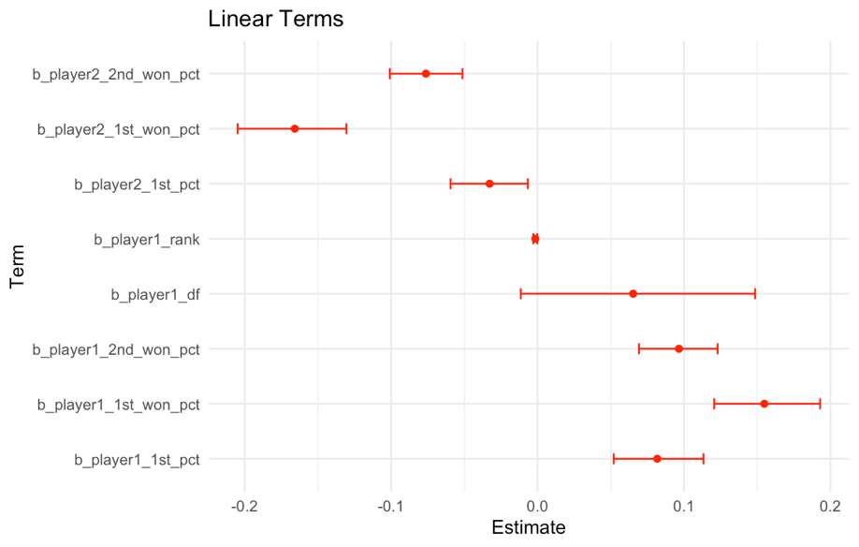
Final models were derived from GAM models to ensure that the best-fitting model was accounted for before fitting Bayesian models. Bayesian models were fitted for breakpoints converted and breakpoint chances for outcome models, as well as breakpoint conversion with differences for the point binomial model.

Figure 30: Confidence intervals for Bayesian analysis for linear terms in the breakpoints converted model

The summary for the breakpoints converted model shows small confidence intervals for all variables, except for double faults, as demonstrated in Figure 30. Double faults had a minor statistical significance, so the Bayesian model suggested it was not crucial for the model, as the variable passed through zero. All variables converged well to 1; however, rank had an estimate of 0, and the credible interval collapsed to zero, suggesting that the variable had no effect in the fitted model. Rank always had a low statistical significance, so it may not be adding any relevant information to the model. The LOO-CV results show that Pareto k estimates < 0.67, meaning that the LOO approximation is reliable, and the MCSE of 0.1 is very small, so the forecast is stable.
Figure 31 shows the curve for breakpoints converted as the number increases for the player.

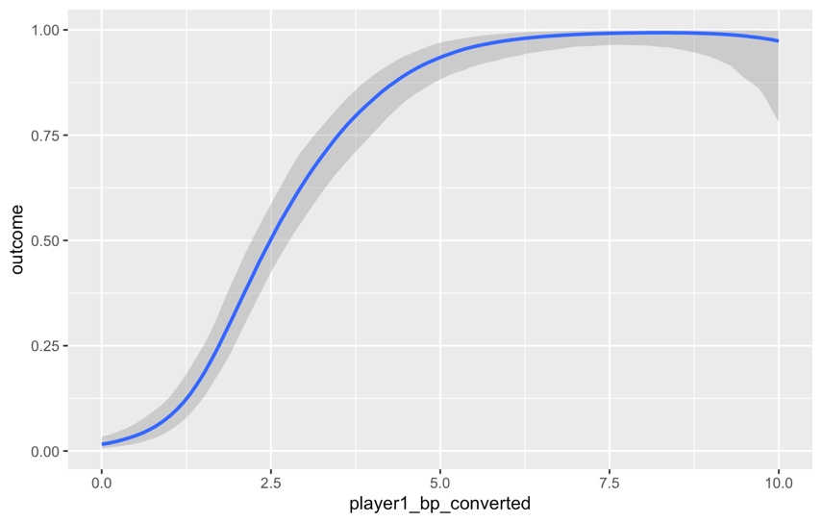
Figure 31: Player breakpoints converted behaviour

As Player 1's breakpoints converted increase, the chances of winning increase; however, this effect plateaus at 5 breakpoints converted. As discussed earlier, in a tennis match, if a player consistently holds their serve, only 2 or 3 break points are needed to win the match. Therefore, more break points will only change the ease of winning the match.
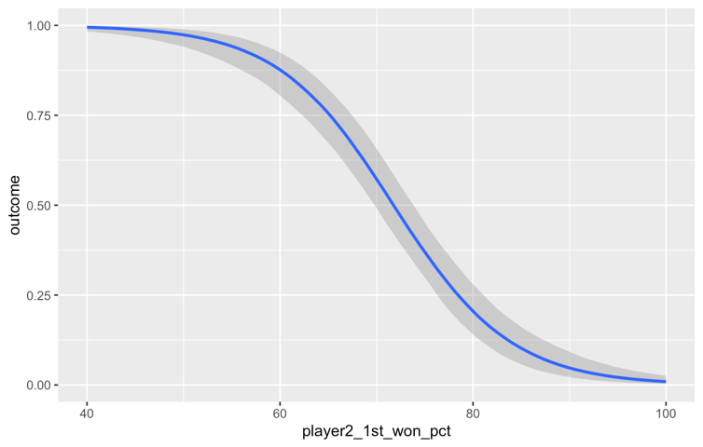
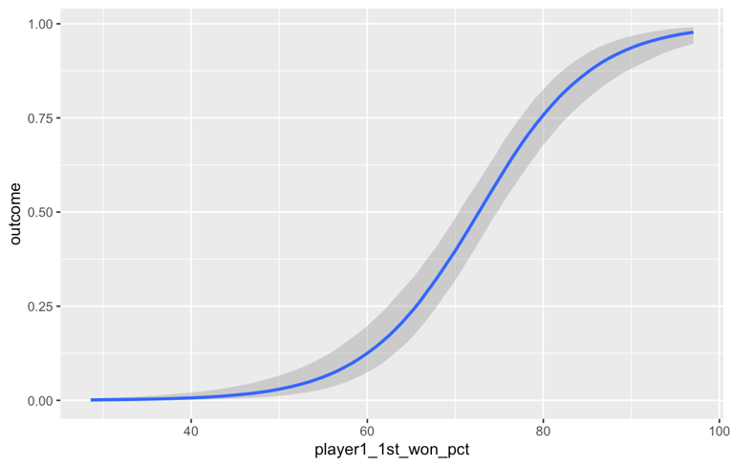
The model regarding breakpoint chances also showed small confidence intervals and no zero inclusion. LOO-CV showed weaker results than the previous model; however, this is expected due to the breakpoint converted variable being very strong, as indicated earlier. Figure 32 shows the curvature of the variables with the smoothing spline.
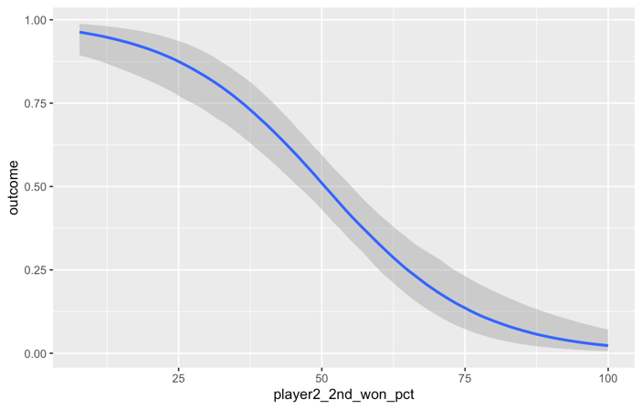

Figure 32: Curvature of non-linear variables in the breakpoint chances model

Player 1’s 1st serve percentage points won significantly impacted the outcome, ranging from 65% to 80%. However, values outside this percentage do not have a significant effect on the outcome, as they indicate that the player is most likely to have lost or won the match. The same trend can be observed for player 2, with a decreasing curve in the percentage of points won on the 1st serve. This is due to it displaying the opponent’s statistics and how they affect player 1’s ability to win the match. Player 2’s 2nd serve percentage points won demonstrated a less steep curve, as this variable was not as powerful as the 1st serve percentage points won, which meant that changes will not be as detrimental to the player. The grey surrounding area was larger with 2nd serves, indicating a larger confidence interval and more fluctuations in the results. These curves show that tennis is played between small margins, and it is essential to stay within a certain percentage to maximise the chance of winning the match.
The binomial points model also showed extremely narrow confidence intervals and convergence, confirming that the models are powerful at explaining what can happen in a tennis match.
3.7 Predictive Modelling
3.7.1 Methods
A predictive modelling framework was developed to estimate the probability of a player winning a tennis match using only historical performance features, player form indicators, and match-level covariates. Using the ATP dataset, the data was restructured so that each row corresponded to a player’s perspective of a single match. Each row contained both the player’s statistics and their opponent’s rolling statistics, allowing head-to-head feature comparisons. To investigate recent performance, a rolling average was calculated across the previous five matches for each player. All the statistics were accounted for, including the duration of the match, as well as a form index that counted the number of wins across the last four matches, and a weighted form index, where more recent matches held more significance.
To account for repeated measures and within-match dependencies, mixed-effects logistic regression models using ‘glmer’ were fitted for match and player identity, as well as a model combining both. The ‘sandwich’ package was installed to adjust for the dependence between rows representing the same match.
To assess predictive performance in a sequential setting, a rolling-forward cumulative validation procedure was implemented. Matches were in chronological order, and for each match, models were trained on all preceding matches, with a minimum of 5 matches required. Predictions were then made for that current match. All matches where players had not played five previous matches were ignored, as no prior performance can be measured. Due to the relatively short clay and grass season, the direct change in surface was not accounted for when analysing performance. However, the rolling average may be more reliable at the French Open and Wimbledon, as these tournaments represent the end of that surface’s season. Head-to-head results were not recorded because the information was unavailable, and players rarely play each other multiple times throughout a season. Performance was assessed using cumulative accuracy, AUC, and a confusion matrix. This was then visualised by plotting AUC and accuracy over time to see how performance accuracy increased and when the results stopped improving.
3.7.2 Results
After creating the new data set, it was tested on the full dataset to identify the most important predictors. After ensuring that observations within the same match were not treated as independent, the model indicated that the difference between aces for opponents and players was only slightly statistically significant, with a p-value of 0.07. Additionally, the double faults and weighted form variable did not show any statistical significance. This is because the number of wins over the last four matches showed more significance, hiding the weighted form variable. All other variables were significant and, therefore, used for the rolling-forward validation function. Table 8 was used to analyse the variables in the model further.
Table 8: Model for predictions using rolling forward averages
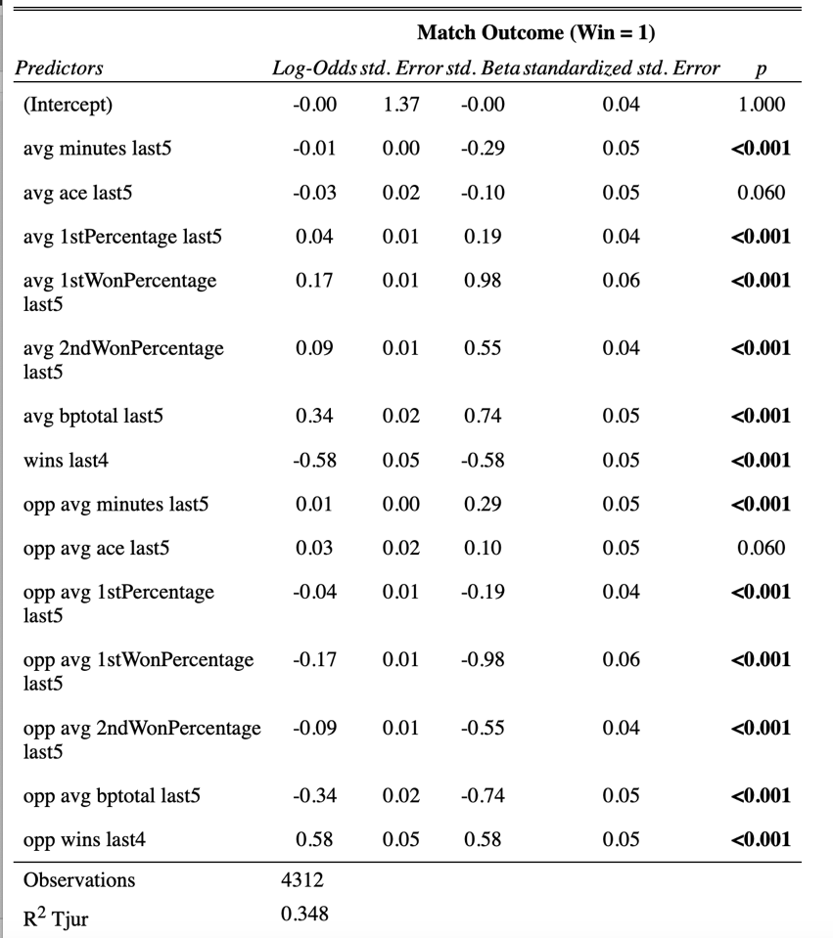

As expected, serve percentages variables, and breakpoint chances have a strong positive effect on the player winning the match. This was evident throughout the earlier modelling stage, where the importance of variables was investigated. Longer match durations did decrease the chance of winning, suggesting fatigue carries over; however, a small log-odds estimate can indicate this is a highly marginal effect. Player aces also had a negative estimate, showing a marginally lower chance of winning. As discussed earlier, this is counterintuitive and may suggest a reliance on aces as a mask for underlying weaknesses. Wins over the last four matches had a strong negative estimate, indicating that players who had more wins are less likely to win their next match. This also may seem counterintuitive, as a player’s form should carry through. However, as a player wins more matches, they play against tougher opponents, which is highlighted by this variable. All these findings are then reversed when examining the opponents’ variables.
Regarding the scale of the estimates, wins last4 and bptotal are on a scale of 1 to 4 and 1 to 10, respectively. As the log odds estimate measures a 1-unit change, a greater effect will be seen in comparison to the percentage. This doesn’t mean they are more impactful; they represent a scale difference.
Before investigating the predictions, mixed-effects models were computed and analysed. These included using random effects with the intercept for match ID, player, and both together. As there were two rows per match, one for each player, the observations are paired and not independent. Adding a random effect with match ID can capture within-match correlation. This showed no impact on the model. Next, a random effect for a player was introduced. With multiple observations per player, the baseline ability varies across players, as some may consistently win while others consistently lose. This allows each player to have their own intercept, absorbing unobserved ability which was not captured by fixed effects. When initially computing this, warning messages appeared regarding convergence. To address these issues, predictors were scaled and modified using the glmerControl to facilitate algorithm convergence. This improved the AIC by 32 and showed a variance of 0.22, meaning some players performed above or below the average baseline. There was player-to-player heterogeneity in baseline outcome, and the model now captures this. This will make more realistic uncertainty estimates and less biased fixed effects. When incorporating player and match ID, there were no improvements to the model fit.
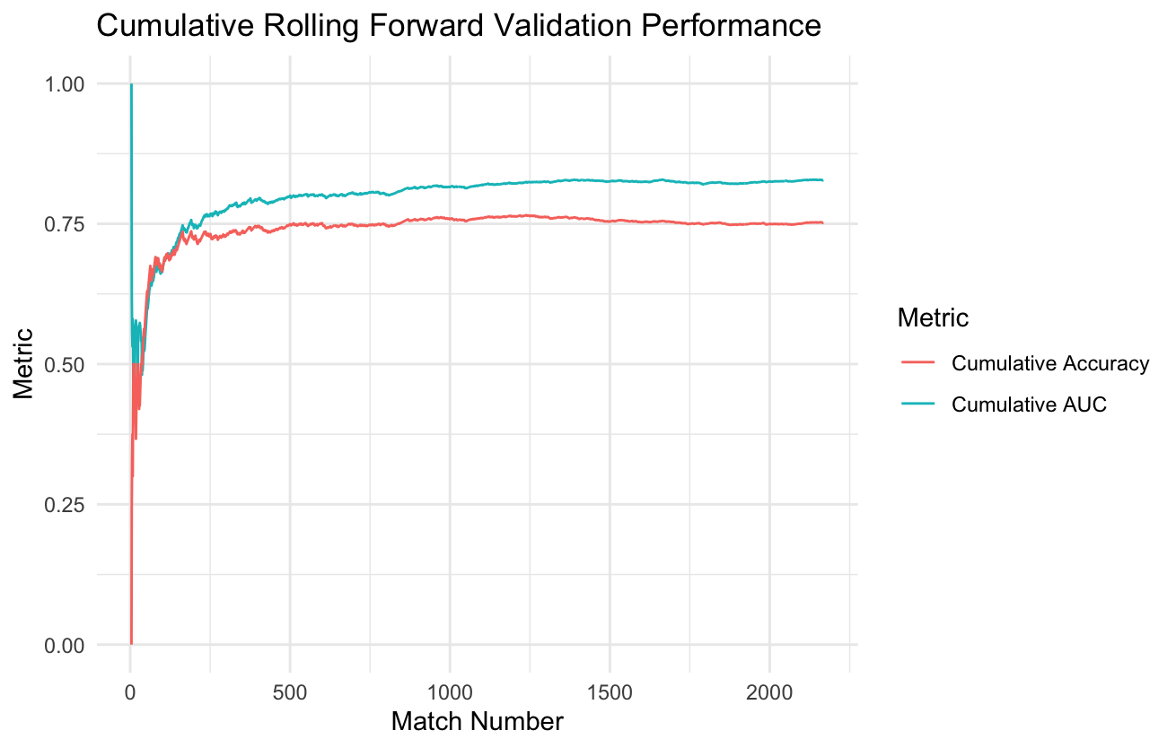
When running the function to compute predictive accuracy, the random effects were ignored due to computational complexity. Accuracy measures how often the model predicts the correct outcome when the threshold for probability is 0.5. AUC, or the area under the curve, indicates how effectively it can distinguish winners from losers across all possible thresholds. Figure 33 shows how the accuracy and AUC values changed as more matches were added to the training data.

Figure 33: Cumulative rolling forward validation performance for Accuracy and AUC

Analysing Figure 33, after 500 matches, the cumulative accuracy remained constant, with a predictive accuracy of 0.75. Although the cumulative AUC continued to increase gradually, it remained steady at around 1200 matches, with a value of 0.83. There was a slight increase in cumulative accuracy at around 1200 matches, with a maximum cumulative accuracy of 0.765, but this dropped back to 0.75, potentially due to fatigue as the season progressed. The confusion matrix demonstrated equal specificity and sensitivity, indicating that the model performs equally well in detecting wins and losses, resulting in a balanced and unbiased prediction.
Overall, the model demonstrated excellent predictive capabilities, and it would be interesting if live data were made readily available, as this could benefit individuals making betting decisions. It is essential to see that match number 500 correlated with the start of April. After 4 months of results, the model accurately predicted the match outcome with 75% accuracy when the threshold was set to 0.5 and 83% accuracy when using all possible thresholds.
3.8 Further Research
Further research in tennis data modelling could investigate vital match statistics within doubles, women’s tennis, different men’s tennis tours, such as Challengers and ITFs, as well as junior tennis. Due to the way these circuits operate, different match statistics may become more critical, as the serve may not be as dominant in women’s tennis and junior tennis, so more emphasis could be placed on the return. Doubles offer different match statistics, such as serve location, and volleys have a massive impact on a doubles match. Given that service statistics heavily dominated this study, findings on winners and unforced errors for both forehands and backhands could enhance coaching interpretability and aid in predictive modelling. With the increased use of Hawk-Eye and electronic line calling, more enhanced data will be available for analysts to create more precise predictions about specific players, helping coaches and players create detailed plans when playing against specific opponents.

References
Bozděch, M., Puda, D., Grasgruber, P. (2024). A detailed analysis of game statistics of professional tennis players: An inferential and machine learning approach. PLOS ONE 19(11): e0309085. https://doi.org/10.1371/journal.pone.0309085
Clarke, S. R., & Dyte, D. (2000). Using official ratings to simulate major tennis tournaments. International Transactions in Operational Research, 7, 585–594.
Gorgi, P., Koopman, S. J., Lit, R. (2019). The Analysis and Forecasting of Tennis Matches by using a High Dimensional Dynamic Model, Journal of the Royal Statistical Society Series A: Statistics in Society, Volume 182, Issue 4, October 2019, Pages 1393–1409, https://doi.org/10.1111/rssa.12464
Klaasen, F., & Magnus, J. R. (2003). Forecasting the winner of a tennis match. European Journal of Operational Research, 148,257–267.
Ma, S. M., Liu, C. C., Tan, Y., & Ma, S. C. (2013). Winning matches in Grand Slam men’s singles: An analysis of player performance-related variables from 1991 to 2008. Journal of Sports Sciences, 31(11), 1147–1155. https://doi.org/10.1080/02640414.2013.775472
Makino, M., Odaka, T., Kuroiwa, J., Suwa, I., Shirai, H. (2020). Feature selection to win the point of ATP tennis players using rally information. International Journal of Computer Science in Sport, 19(1), 37-50. https://doi.org/10.2478/ijcss-2020-0003
Mchale, I., & Morton, A. (2011). A Bradley-Terry type model for forecasting tennis match results. International Journal of Forecasting, DOI: 10.1016/j.ijforecast.2010.04.004
Mecheri, S., Rioult, F., Mantel, B., Kauffmann, F., Benguigui, N. (2016). The serve impact in tennis: First large-scale study of big Hawk-Eye data. Statistical Analysis and Data Mining: The ASA Data Science Journal, 9, 310-325.
Reid, M., McMurtrie, D., Crespo, M. (2010). The relationship between match statistics and top 100 ranking in professional men's tennis. International Journal of Performance Analysis in Sport, 10(2), 131-138. https://doi.org/10.1080/24748668.2010.11868509

Appendices
# Import Dataset
atp<-read.csv("atp_matches_2024.csv")
atp
# View names of columns
names(atp)
# See the number of rows and columns
dim(atp)
# Investigate the classes of the features
sapply(atp,class)
# Load Tidyverse package
library(tidyverse)
# Add Specific match id to rows
atp <- mutate(atp, match_id = row_number())
# View section of the dataset
tibble(atp)
# Investigate if there are rows containing NA values
sum(is.na(atp))
summary(is.na(atp))
# Investigate if there are rows where the aces are NA values
sum(is.na(atp$w_ace))
# Remove rows where serve stats had NA values
atp<- atp[!is.na(atp$w_ace),]
atp <- atp[!is.na(atp$w_SvGms),]
atp <- atp[!is.na(atp$l_SvGms),]
# Create Percentage columns for serve statistics
atp$w_1stPercentage <- (atp$w_1stIn/atp$w_svpt) * 100
atp$w_1stWonPercentage <- (atp$w_1stWon/atp$w_1stIn) * 100
atp$w_2ndWonPercentage <- (atp$w_2ndWon/(atp$w_svpt-atp$w_1stIn)) *100
atp$l_1stPercentage <- (atp$l_1stIn/atp$l_svpt) * 100
atp$l_1stWonPercentage <- (atp$l_1stWon/atp$l_1stIn) * 100
atp$l_2ndWonPercentage <- (atp$l_2ndWon/(atp$l_svpt-atp$l_1stIn)) *100
# Create columns for serve and return points won
atp$w_svptsWon <- (atp$w_1stWon + atp$w_2ndWon)
atp$l_svptsWon <- (atp$l_1stWon + atp$l_2ndWon)
atp$w_returnWon <- (atp$l_svpt -(atp$l_1stWon + atp$l_2ndWon))
atp$l_returnWon <- (atp$w_svpt - (atp$w_1stWon + atp$w_2ndWon))
# Create total points column
atp$total_match_points <- (atp$w_svpt + atp$l_svpt)
# Create total points won for winner and loser
atp$w_totalpointsWon <- (atp$w_svptsWon + atp$w_returnWon)
atp$l_totalpointsWon <- (atp$l_svptsWon + atp$l_returnWon)
# Create columns for return percentage points won
atp$w_returnpointsWonPercentage <- (atp$w_returnWon/atp$l_svpt) * 100
atp$l_returnpointsWonPercentage <- (atp$l_returnWon/atp$w_svpt) * 100
# Create a break point conversion ratio column
w_numerator <- atp$l_bpFaced-atp$l_bpSaved
w_denominator <- atp$l_bpFaced
atp$w_bpconverted <- paste0(w_numerator, "/", w_denominator)
l_numerator <- atp$w_bpFaced-atp$w_bpSaved
l_denominator <- atp$w_bpFaced
atp$l_bpconverted <- paste0(l_numerator, "/", l_denominator)
# Investigate for duplicated values
table(duplicated(atp))
# Investigate summary statistics
summary(atp)
# Look at names of all the players that won
unique(atp$winner_name)
# Only allow percentages equal or less than 100
atp <- atp[atp$w_2ndWonPercentage <=100,]
# Investigate any NA values in tourney ID
sum(is.na(atp$tourney_id))
# Remove rows containing NA values
atp<- atp[!is.na(atp$tourney_id),]
atp<- atp[!is.na(atp$l_2ndWonPercentage),]
# Separating the break points converted columns into integers and then into a ratio for analysis
atp <- atp %>%
separate(w_bpconverted, into = c("w_bpconverted", "w_bptotal"),sep = "/", convert =TRUE) %>%
separate(l_bpconverted, into = c("l_bpconverted", "l_bptotal"), sep = "/", convert = TRUE) %>%
mutate(
w_bp_conversion_percentage = ifelse(w_bptotal == 0 & w_bpconverted == 0, 0, w_bpconverted/w_bptotal * 100),
l_bp_conversion_percentage = ifelse(l_bptotal == 0 & l_bpconverted == 0, 0, l_bpconverted/l_bptotal * 100)
)
# Add total Aces column
atp <- atp %>%
mutate(total_aces = w_ace +l_ace)
# Add Total Double Faults column
atp <- atp %>%
mutate(total_dfs = w_df + l_df)
# Load Libraries for data wrangling
library(dplyr)
library(tidyr)
# Import ggplot for data visualisations
library(ggplot2)
# Create a bar chart for number of matches on each surface
ggplot(atp, aes(x = surface, fill = surface))+
geom_bar() +
labs(title = "Count of Matches by Surface",
x = "Surface",
y = "Number of Matches") +
theme_minimal()

# Create a boxplot for the height of players
atp$loser_ht[atp$match_id == 2917] <- 180
height_data <- atp %>%
dplyr::select(winner_ht, loser_ht) %>%
pivot_longer(cols = everything(), values_to = "height") %>%
filter(!is.na(height))
ggplot(height_data, aes(y = height )) +
geom_boxplot(fill = "skyblue", color = "black") +
labs(title = "Distribution of Player Heights",
y = "Height (cm)") +
theme_minimal()

# Boxplot for Age
age_data <- atp %>%
dplyr::select(winner_age, loser_age) %>%
pivot_longer(cols = everything(), values_to = "age") %>%
filter(!is.na(age))
ggplot(age_data, aes(y = age)) +
geom_boxplot(fill = "skyblue", color = "black") +
labs(title = "Distribution of Player Ages",
y = "Age") +
theme_minimal()

# Create table to see what countries have the most players and most wins
match_wins <- atp %>%
count(winner_ioc, name = "matches_won") %>%
arrange(desc(matches_won))
match_wins
players <- atp %>%
dplyr::select(winner_name, winner_ioc) %>%
rename(player = winner_name, country = winner_ioc) %>%
bind_rows(
atp %>%
dplyr::select(loser_name, loser_ioc) %>%
rename(player = loser_name, country = loser_ioc)
) %>%
distinct()
player_freq <- players %>%
count(country, name = "player_count") %>%
arrange(desc(player_count))
player_freq
country_stats <- full_join(match_wins, player_freq, by = c("winner_ioc" = "country")) %>%
rename(country = winner_ioc) %>%
replace_na(list(matches_won = 0, player_count = 0))
country_stats

# Long format for grouped bar chart
country_stats_long <- country_stats %>%
pivot_longer(cols = c(matches_won, player_count),
names_to = "metric",
values_to = "count") %>%
slice(1:20)
country_stats_long

# grouped bar chart to show countries with most wins and player count
ggplot(country_stats_long, aes(x = reorder(country, -count), y = count, fill = metric)) +
geom_bar(stat = "identity", position = "dodge") +
labs(title = "Matches Won and Player Count by Country",
x = "Country",
y = "Count",
fill = "Metric") +
theme_minimal() +
theme(axis.text.x = element_text(angle = 90,hjust = 1))

# Create boxplots for Serve statistics
boxplot(atp$w_1stPercentage,atp$l_1stPercentage, col = c("green","red"),main = "Boxplot of Winner 1st Serve % vs Loser 1st Serve %")
boxplot(atp$w_1stWonPercentage,atp$l_1stWonPercentage, col = c("green","red"),main = "Boxplot of Winner 1st Serve % Points Won vs Loser 1st Serve % Points Won")
boxplot(atp$w_2ndWonPercentage,atp$l_2ndWonPercentage, col = c("green","red"),main = "Boxplot of Winner 2nd Serve % Points Won vs Loser 2nd Serve % Points Won")

# Create a table for 1st Serve % by surface
first_serve_pct <- atp %>%
dplyr::select(surface,w_1stPercentage,l_1stPercentage) %>%
pivot_longer(cols = c(w_1stPercentage,l_1stPercentage), names_to = "player_type", values_to = "conversion_rate")

# Create bar chart for Winner 1st Serve % by Surface
first_serve_pct %>%
group_by(surface, player_type) %>%
summarise(mean_rate = mean(conversion_rate, na.rm = TRUE)) %>%
ggplot(aes(x = surface, y = mean_rate, fill = player_type)) +
geom_col(position = position_dodge()) +
labs(title = "Mean 1st Serve % by Surface and Player Type",
x = "Surface",
y = "%") +
theme_minimal()
# Create table to view 1st Serve % Points Won by Surface
first_serve <- atp %>%
dplyr::select(surface,w_1stWonPercentage,l_1stWonPercentage) %>%
pivot_longer(cols = c(w_1stWonPercentage,l_1stWonPercentage), names_to = "player_type", values_to = "conversion_rate")
first_serve
# Create Boxplot for 1st Serve % Points Won by Surface
ggplot(first_serve, aes(x = surface, y = conversion_rate, fill = player_type)) +
geom_boxplot(position = position_dodge()) +
labs(title = "1st Serve Points Won by Surface and Player Type",
x = "Surface",
y = "% Points Won") +
theme_minimal()
# Create bar chart to view Mean 1st Serve % Points Won by Surface
first_serve %>%
group_by(surface, player_type) %>%
summarise(mean_rate = mean(conversion_rate, na.rm = TRUE)) %>%
ggplot(aes(x = surface, y = mean_rate, fill = player_type)) +
geom_col(position = position_dodge()) +
labs(title = "Mean 1st Serve Points Won by Surface and Player Type",
x = "Surface",
y = "% Points Won") +
theme_minimal()

# Create table for 2nd Serve % Points Won by Surface
second_serve <- atp %>%
dplyr::select(surface,w_2ndWonPercentage,l_2ndWonPercentage) %>%
pivot_longer(cols = c(w_2ndWonPercentage,l_2ndWonPercentage), names_to = "player_type", values_to = "conversion_rate")
# Create boxplot for 2nd Serve % Points Won by Surface
ggplot(second_serve, aes(x = surface, y = conversion_rate, fill = player_type)) +
geom_boxplot(position = position_dodge()) +
labs(title = "2nd Serve Points Won by Surface and Player Type",
x = "Surface",
y = "% Points Won") +
theme_minimal()
# Create bar chart for 2nd Serve % Points Won by Surface
second_serve %>%
group_by(surface, player_type) %>%
summarise(mean_rate = mean(conversion_rate, na.rm = TRUE)) %>%
ggplot(aes(x = surface, y = mean_rate, fill = player_type)) +
geom_col(position = position_dodge()) +
labs(title = "Mean 2nd Serve Points Won by Surface and Player Type",
x = "Surface",
y = "% Points Won") +
theme_minimal()

# Create table for Mean Total Aces by Surface
aces_by_surface <- atp %>%
group_by(surface) %>%
summarise(mean_total_aces = mean(total_aces, na.rm = TRUE))
# Create Bar Chart for Mean Total Aces per Match by Surface
ggplot(aces_by_surface, aes(x = surface, y = mean_total_aces, fill = surface)) +
geom_col() +
labs(title = "Mean Total Aces per Match by Surface",
x = "Surface", y = "Mean Total Aces") +
theme_minimal()
# Create table for Mean Total Double Faults by Surface
dfs_by_surface <- atp %>%
group_by(surface) %>%
summarise(mean_total_dfs = mean(total_dfs, na.rm = TRUE))
# Create Bar Chart for Mean Total Double Faults by Surface
ggplot(dfs_by_surface, aes(x= surface, y = mean_total_dfs, fill = surface)) +
geom_col() +
labs(title = "Mean Total Double Faults per Match by Surface",
x = "Surface", y = "Mean Total Double Faults") +
theme_minimal()

# Create density graphs with aces for Winners and Losers
ggplot() +
geom_density(aes(x = atp$w_ace, color = "Winner"), adjust = 1.5) +
geom_density(aes(x = atp$l_ace, color = "Loser"), adjust = 1.5) +
scale_color_manual(values = c("Winner" = "blue", "Loser" = "red")) +
labs(title = "Density of Aces: Winner vs Loser",
x = "Number of Aces",
y = "Density",
color = "Player") +
theme_minimal()
# Create Density graphs for double faults for Winners and Losers
ggplot() +
geom_density(aes(x = atp$w_df, color = "Winner"), adjust = 2) +
geom_density(aes(x = atp$l_df, color = "Loser"), adjust = 2) +
scale_color_manual(values = c("Winner" = "blue", "Loser" = "red")) +
labs(title = "Density of Double Faults: Winner vs Loser",
x = "Number of Double Faults",
y = "Density",
color = "Player") +
theme_minimal()
# Look at summary aces statistics
summary(atp$w_ace)
summary(atp$l_ace)

# Producing a longer format to establish breakpoint conversion percentage for the winner and loser and the value
bp_long <- atp %>%
dplyr::select(surface,w_bp_conversion_percentage,l_bp_conversion_percentage) %>%
pivot_longer(cols = c(w_bp_conversion_percentage,l_bp_conversion_percentage), names_to = "player_type", values_to = "conversion_percentage")
bp_long

# Boxplot to show breakpoint conversion percentage of winner and losers.
ggplot(bp_long, aes(x = player_type, y= conversion_percentage, fill = player_type)) +
geom_boxplot() +
labs(title = "Break Point Conversion: Winner vs Loser",
x = "", y ="Conversion %") +
theme_minimal()
# Create a boxplot to view Breakpoint Conversion percentage by Surface
ggplot(bp_long, aes(x = surface, y = conversion_percentage, fill = player_type)) +
geom_boxplot(position = position_dodge()) +
labs(title = "Break Point Conversion by Surface and Player Type",
x = "Surface",
y = "Conversion %") +
theme_minimal()
# Create a bar chart to view Mean Break Point Conversion by Surface
bp_long %>%
group_by(surface, player_type) %>%
summarise(mean_rate = mean(conversion_percentage, na.rm = TRUE)) %>%
ggplot(aes(x = surface, y = mean_rate, fill = player_type)) +
geom_col(position = position_dodge()) +
labs(title = "Mean Break Point Conversion by Surface and Player Type",
x = "Surface",
y = "Mean Conversion %") +
theme_minimal()

# Producing a longer format to establish breakpoints converted for the winner and loser and the value
bp_converted <- atp %>%
dplyr::select(surface,w_bpconverted,l_bpconverted) %>%
pivot_longer(cols = c(w_bpconverted,l_bpconverted), names_to = "player_type", values_to = "converted")
bp_converted

# Boxplot to show break point converted for winner and losers.
ggplot(bp_converted, aes(x = player_type, y= converted, fill = player_type)) +
geom_boxplot() +
labs(title = "Break Points Converted: Winner vs Loser",
x = "", y ="Breaks") +
theme_minimal()
# Create a boxplot to view Break Points Converted by Surface
ggplot(bp_converted, aes(x = surface, y = converted, fill = player_type)) +
geom_boxplot(position = position_dodge()) +
labs(title = "Break Points Converted by Surface and Player Type",
x = "Surface",
y = "Breaks") +
theme_minimal()
# Create a bar chart to view Mean Break Point Converted by Surface
bp_converted %>%
group_by(surface, player_type) %>%
summarise(mean_rate = mean(converted, na.rm = TRUE)) %>%
ggplot(aes(x = surface, y = mean_rate, fill = player_type)) +
geom_col(position = position_dodge()) +
labs(title = "Mean Break Points Converted by Surface and Player Type",
x = "Surface",
y = "Breaks") +
theme_minimal()

# Producing a longer format to establish breakpoint chances for the winner and loser and the value
bp_chances <- atp %>%
dplyr::select(surface,w_bptotal,l_bptotal) %>%
pivot_longer(cols = c(w_bptotal,l_bptotal), names_to = "player_type", values_to = "chances")
bp_chances

# Boxplot to show break point chances for winner and losers.
ggplot(bp_chances, aes(x = player_type, y= chances, fill = player_type)) +
geom_boxplot() +
labs(title = "Break Point Chances: Winner vs Loser",
x = "", y ="Chances") +
theme_minimal()
# Create a boxplot to view Break Points Chances by Surface
ggplot(bp_chances, aes(x = surface, y = chances, fill = player_type)) +
geom_boxplot(position = position_dodge()) +
labs(title = "Break Point Chances by Surface and Player Type",
x = "Surface",
y = "Break Chances") +
theme_minimal()
# Create a bar chart to view Mean Break Point Chances by Surface
bp_chances %>%
group_by(surface, player_type) %>%
summarise(mean_rate = mean(chances, na.rm = TRUE)) %>%
ggplot(aes(x = surface, y = mean_rate, fill = player_type)) +
geom_col(position = position_dodge()) +
labs(title = "Mean Break Point Chances by Surface and Player Type",
x = "Surface",
y = "Break Chances") +
theme_minimal()
# Data Modelling
# Set seed for reproducibility
set.seed(1)
# New format for modelling
atp_balanced <- atp %>%
filter(!is.na(winner_name), !is.na(loser_name)) %>%
filter(!is.na(minutes), minutes >= 43) %>%
filter(!is.na(winner_rank), !is.na(loser_rank)) %>%
mutate(flip = sample(c(TRUE, FALSE), n(), replace = TRUE)) %>%
transmute(
outcome = ifelse(flip, 1, 0),
surface = factor(surface),
duration = as.numeric(minutes),
match_date = as.Date(as.character(tourney_date), format = "%Y%m%d"),

# Assign player 1 and player 2 stats based on flip
player1_total_points_won = ifelse(flip, w_totalpointsWon, l_totalpointsWon),
player2_total_points_won = ifelse(flip, l_totalpointsWon, w_totalpointsWon),
total_match_points,

player1_ace = ifelse(flip, w_ace, l_ace),
player2_ace = ifelse(flip, l_ace, w_ace),

player1_df = ifelse(flip, w_df, l_df),
player2_df = ifelse(flip, l_df, w_df),

player1_1st_pct = ifelse(flip, w_1stPercentage, l_1stPercentage),
player2_1st_pct = ifelse(flip, l_1stPercentage, w_1stPercentage),

player1_1st_won_pct = ifelse(flip, w_1stWonPercentage, l_1stWonPercentage),
player2_1st_won_pct = ifelse(flip, l_1stWonPercentage, w_1stWonPercentage),

player1_2nd_won_pct = ifelse(flip, w_2ndWonPercentage, l_2ndWonPercentage),
player2_2nd_won_pct = ifelse(flip, l_2ndWonPercentage, w_2ndWonPercentage),

player1_return_won_pct = ifelse(flip, w_returnpointsWonPercentage, l_returnpointsWonPercentage),
player2_return_won_pct = ifelse(flip, l_returnpointsWonPercentage, w_returnpointsWonPercentage),

player1_bp_converted = ifelse(flip, w_bpconverted, l_bpconverted),
player2_bp_converted = ifelse(flip, l_bpconverted, w_bpconverted),

player1_bp_conversion_pct = ifelse(flip, w_bp_conversion_percentage, l_bp_conversion_percentage),
player2_bp_conversion_pct = ifelse(flip, l_bp_conversion_percentage, w_bp_conversion_percentage),

player1_bp_chances = ifelse(flip, w_bptotal, l_bptotal),
player2_bp_chances = ifelse(flip, l_bptotal, w_bptotal),

player1_rank = ifelse(flip, winner_rank, loser_rank),
player2_rank = ifelse(flip, loser_rank, winner_rank),

# Differences between variables
aces_diff = ifelse(flip, w_ace - l_ace, l_ace - w_ace),
double_faults_diff = ifelse(flip, w_df - l_df, l_df - w_df),
first_serve_pct_diff = ifelse(flip, w_1stPercentage - l_1stPercentage, l_1stPercentage - w_1stPercentage),
first_serve_won_pct_diff = ifelse(flip, w_1stWonPercentage - l_1stWonPercentage, l_1stWonPercentage - w_1stWonPercentage),
second_serve_won_pct_diff = ifelse(flip, w_2ndWonPercentage - l_2ndWonPercentage, l_2ndWonPercentage - w_2ndWonPercentage),
return_points_won_pct_diff = ifelse(flip, w_returnpointsWonPercentage - l_returnpointsWonPercentage, l_returnpointsWonPercentage - w_returnpointsWonPercentage),
break_points_converted_diff = ifelse(flip, w_bpconverted - l_bpconverted, l_bpconverted - w_bpconverted),
break_points_conversion_pct_diff = ifelse(flip, w_bp_conversion_percentage - l_bp_conversion_percentage, l_bp_conversion_percentage - w_bp_conversion_percentage),
break_points_chances_diff = ifelse(flip, w_bptotal - l_bptotal, l_bptotal - w_bptotal),
ranking_diff = ifelse(flip, loser_rank - winner_rank, winner_rank - loser_rank)
)

# View new format
glimpse(atp_balanced)
# Investiagte number of rows for each outcome
table(atp_balanced$outcome)
# Set minimum value
min_size <- min(table(atp_balanced$outcome))
# Adapt dataset to remove extra losses
atp_balanced <- atp_balanced %>%
group_by(outcome) %>%
slice_sample(n = min_size) %>%
ungroup()
# View to ensure equal measure of outcomes
table(atp_balanced$outcome)
# Create match date number for order
atp_balanced$match_date_num <- as.numeric(atp_balanced$match_date - as.Date("2024-01-01"))
# Model with all variables
model1_ind <- glm(
outcome ~ surface + duration + match_date_num +
player1_ace + player2_ace +
player1_df + player2_df +
player1_1st_pct + player2_1st_pct +
player1_1st_won_pct + player2_1st_won_pct +
player1_2nd_won_pct + player2_2nd_won_pct +
player1_bp_converted + player2_bp_converted +
player1_bp_conversion_pct + player2_bp_conversion_pct +
player1_bp_chances + player2_bp_chances +
player1_rank + player2_rank,
data = atp_balanced,
family = binomial()
)

summary(model1_ind)
# Import car to check multicolinearity
library(car)

# Check for co-linearity and correlations
vif(model1_ind)
cor(atp_balanced$outcome, atp_balanced$player1_bp_converted)
cor(atp_balanced$outcome, atp_balanced$player1_bp_conversion_pct)
cor(atp_balanced$outcome,atp_balanced$player1_bp_chances)
cor(atp_balanced$outcome, atp_balanced$player1_1st_won_pct, use = "complete.obs")
cor(atp_balanced$player1_1st_won_pct, atp_balanced$player1_bp_converted)
cor(atp_balanced$player1_rank, atp_balanced$player2_rank)
cor(atp_balanced$player1_bp_converted, atp_balanced$player1_bp_conversion_pct, use = "complete.obs")
cor(atp_balanced$player1_bp_chances, atp_balanced$player1_bp_converted, use = "complete.obs")
# Focus on Break Points converted as first Break point variable
model2_ind <- glm(
outcome ~ surface + duration + match_date_num +
player1_ace + player2_ace +
player1_df + player2_df +
player1_1st_pct + player2_1st_pct +
player1_1st_won_pct + player2_1st_won_pct +
player1_2nd_won_pct + player2_2nd_won_pct +
player1_bp_converted + player2_bp_converted +
player1_rank + player2_rank,
data = atp_balanced,
family = binomial()
)

summary(model2_ind)
# Check for co-linearity
vif(model2_ind)

# Change rank of players to ranking difference
model3_ind <- glm(
outcome ~ surface + duration + match_date_num +
player1_ace + player2_ace +
player1_df + player2_df +
player1_1st_pct + player2_1st_pct +
player1_1st_won_pct + player2_1st_won_pct +
player1_2nd_won_pct + player2_2nd_won_pct +
player1_bp_converted + player2_bp_converted +
ranking_diff,
data = atp_balanced,
family = binomial()
)

summary(model3_ind)

# Change rank difference to player rank
model3.5_ind <- glm(
outcome ~ surface + duration + match_date_num +
player1_ace + player2_ace +
player1_df + player2_df +
player1_1st_pct + player2_1st_pct +
player1_1st_won_pct + player2_1st_won_pct +
player1_2nd_won_pct + player2_2nd_won_pct +
player1_bp_converted + player2_bp_converted +
player1_rank,
data = atp_balanced,
family = binomial()
)

summary(model3.5_ind)

# Incorporate a quadratic term for match date in the model
model4_ind <- glm(
outcome ~ surface + duration + match_date_num + I(match_date_num^2) +
player1_ace + player2_ace +
player1_df + player2_df +
player1_1st_pct + player2_1st_pct +
player1_1st_won_pct + player2_1st_won_pct +
player1_2nd_won_pct + player2_2nd_won_pct +
player1_bp_converted + player2_bp_converted +
player1_rank,
data = atp_balanced,
family = binomial()
)

summary(model4_ind)

# Add a cubic term for match date to the model
model5_ind <- glm(
outcome ~ surface + duration + match_date_num + I(match_date_num^2) + I(match_date_num^3) +
player1_ace + player2_ace +
player1_df + player2_df +
player1_1st_pct + player2_1st_pct +
player1_1st_won_pct + player2_1st_won_pct +
player1_2nd_won_pct + player2_2nd_won_pct +
player1_bp_converted + player2_bp_converted +
player1_rank,
data = atp_balanced,
family = binomial()
)

summary(model5_ind)

# Add these a quadratic term for duration to the model
model6_ind <- glm(
outcome ~ surface + duration + I(duration^2) +
match_date_num +
player1_ace + player2_ace +
player1_df + player2_df +
player1_1st_pct + player2_1st_pct +
player1_1st_won_pct + player2_1st_won_pct +
player1_2nd_won_pct + player2_2nd_won_pct +
player1_bp_converted + player2_bp_converted +
player1_rank,
data = atp_balanced,
family = binomial()
)

summary(model6_ind)

# Add a cubic term for duration to the model
model7_ind <- glm(
outcome ~ duration + I(duration^2) + I(duration^3) +
match_date_num + I(match_date_num^2) + I(match_date_num^3) +
player1_ace + player2_ace +
player1_df + player2_df +
player1_1st_pct + player2_1st_pct +
player1_1st_won_pct + player2_1st_won_pct +
player1_2nd_won_pct + player2_2nd_won_pct +
player1_bp_converted + player2_bp_converted +
player1_rank,
data = atp_balanced,
family = binomial()
)

summary(model7_ind)

# Change the baseline of surface to Hard
atp_balanced$surface <- relevel(factor(atp_balanced$surface), ref = "Hard")

model9_ind <- glm(
outcome ~ surface + duration + match_date_num +
player1_ace + player2_ace +
player1_df + player2_df +
player1_1st_pct + player2_1st_pct +
player1_1st_won_pct + player2_1st_won_pct +
player1_2nd_won_pct + player2_2nd_won_pct +
player1_bp_converted + player2_bp_converted +
player1_rank,
data = atp_balanced,
family = binomial()
)

summary(model9_ind)

# Change the baseline of surface to Grass
atp_balanced$surface <- relevel(factor(atp_balanced$surface), ref = "Grass")

model10_ind <- glm(
outcome ~ surface + duration +
match_date_num +
player1_ace + player2_ace +
player1_df + player2_df +
player1_1st_pct + player2_1st_pct +
player1_1st_won_pct + player2_1st_won_pct +
player1_2nd_won_pct + player2_2nd_won_pct +
player1_bp_converted + player2_bp_converted +
player1_rank,
data = atp_balanced,
family = binomial()
)

summary(model10_ind)

# Remove surface, duration, match date number, aces and opponent double faults
model11_ind <- glm(
outcome ~ player1_df +
player1_1st_pct + player2_1st_pct +
player1_1st_won_pct + player2_1st_won_pct +
player1_2nd_won_pct + player2_2nd_won_pct +
player1_bp_converted + player2_bp_converted +
player1_rank,
data = atp_balanced,
family = binomial()
)

summary(model11_ind)

# Load sjplot for clean table to add to report
install.packages("sjPlot")
library(sjPlot)

tab_model(model11_ind, show.ci = FALSE, show.se = TRUE, show.std = TRUE, transform = NULL,
dv.labels = "Match Outcome (Win = 1)")

# Investigate use of break point conversion rate on all variables
model12_ind <- glm(
outcome ~ surface + duration + match_date_num +
player1_ace + player2_ace +
player1_df + player2_df +
player1_1st_pct + player2_1st_pct +
player1_1st_won_pct + player2_1st_won_pct +
player1_2nd_won_pct + player2_2nd_won_pct +
player1_bp_conversion_pct + player2_bp_conversion_pct +
player1_rank,
data = atp_balanced,
family = binomial()
)

summary(model12_ind)

# Remove surface, duration, match date, aces, opponent double faults
model12.5_ind <- glm(
outcome ~ player1_df +
player1_1st_pct + player2_1st_pct +
player1_1st_won_pct + player2_1st_won_pct +
player1_2nd_won_pct + player2_2nd_won_pct +
player1_bp_conversion_pct + player2_bp_conversion_pct +
player1_rank,
data = atp_balanced,
family = binomial()
)

summary(model12.5_ind)

tab_model(model12.5_ind, show.ci = FALSE, show.se = TRUE, show.std = TRUE, transform = NULL,
dv.labels = "Match Outcome (Win = 1)")

cor(atp_balanced$outcome,atp_balanced$player1_bp_converted)
cor(atp_balanced$outcome,atp_balanced$player1_bp_conversion_pct)
cor(atp_balanced$player1_bp_converted,atp_balanced$player1_1st_won_pct)
cor(atp_balanced$player1_1st_won_pct,atp_balanced$player1_bp_conversion_pct)
#Investigate use of break point chances with all variables
model13_ind <- glm(
outcome ~ surface + duration +
match_date_num +
player1_ace + player2_ace +
player1_df + player2_df +
player1_1st_pct + player2_1st_pct +
player1_1st_won_pct + player2_1st_won_pct +
player1_2nd_won_pct + player2_2nd_won_pct +
player1_bp_chances + player2_bp_chances +
player1_rank,
data = atp_balanced,
family = binomial()
)

summary(model13_ind)
cor(atp_balanced$outcome,atp_balanced$player2_bp_chances)

# Remove duration, match date, opponent double faults and player aces
model14_hard_ind <- glm(
outcome ~
player2_ace + surface + player1_df +
player1_1st_pct + player2_1st_pct +
player1_1st_won_pct + player2_1st_won_pct +
player1_2nd_won_pct + player2_2nd_won_pct +
player1_bp_chances + player2_bp_chances +
player1_rank,
data = atp_balanced,
family = binomial()
)
summary(model14_hard_ind)
# Change baseline to Grass
atp_balanced$surface <- relevel(factor(atp_balanced$surface), ref = "Grass")
model14_grass_ind <- glm(
outcome ~
player2_ace + surface + player1_df +
player1_1st_pct + player2_1st_pct +
player1_1st_won_pct + player2_1st_won_pct +
player1_2nd_won_pct + player2_2nd_won_pct +
player1_bp_chances + player2_bp_chances +
player1_rank,
data = atp_balanced,
family = binomial()
)
summary(model14_grass_ind)

# Change baseline to Clay
atp_balanced$surface <- relevel(factor(atp_balanced$surface), ref = "Clay")

model14_clay_ind <- glm(
outcome ~
player2_ace + surface + player1_df +
player1_1st_pct + player2_1st_pct +
player1_1st_won_pct + player2_1st_won_pct +
player1_2nd_won_pct + player2_2nd_won_pct +
player1_bp_chances + player2_bp_chances +
player1_rank,
data = atp_balanced,
family = binomial()
)

summary(model14_clay_ind)
tab_model(model14_clay_ind, show.ci = FALSE, show.se = TRUE, show.std = TRUE, transform = NULL,
dv.labels = "Match Outcome (Win = 1)")
cor(atp_balanced$player2_df, atp_balanced$player2_bp_chances)

# Remove duration, match date, surface, opponent double faults and aces
model14_ind <- glm(
outcome ~
player1_df +
player1_1st_pct + player2_1st_pct +
player1_1st_won_pct + player2_1st_won_pct +
player1_2nd_won_pct + player2_2nd_won_pct +
player1_bp_chances + player2_bp_chances +
player1_rank,
data = atp_balanced,
family = binomial()
)
summary(model14_ind)

model14_noserve_ind <- glm(
outcome ~
player1_df +
player1_bp_chances + player2_bp_chances,
data = atp_balanced,
family = binomial()
)
summary(model14_noserve_ind)
tab_model(model14_noserve_ind, show.ci = FALSE, show.se = TRUE, show.std = TRUE, transform = NULL,
dv.labels = "Match Outcome (Win = 1)")

# Load ggeffects for marginal effects
install.packages("ggeffects")
library(ggeffects)
# Create marginal effects for breakpoint chances with serve statistics
pred_with_serve <- ggeffect(model14_ind, "player1_bp_chances")
pred_with_serve
# Create marginal effects for breakpoint chances without serve statistics
pred_no_serve <- ggeffect(model14_noserve_ind, "player1_bp_chances")
pred_no_serve
pred_no_serve$model <- "Without Serve stats"
pred_with_serve$model <- "With Serve stats"
# Bind tables together
pred_all <- rbind(pred_no_serve, pred_with_serve)
# Produce a graph for marginal effects
ggplot(pred_all, aes(x = x, y = predicted, color = model)) +
geom_line(size = 1.2) +
geom_ribbon(aes(ymin = conf.low, ymax = conf.high, fill = model), alpha = 0.2, color = NA) +
labs(x = "Player 1 Break Point Chances",
y = "Predicted Probability of Winning",
title = "Effect of Break Points with vs without Serve Stats") +
theme_minimal()
# Variable importance for each final model
varImp(model11_ind)
imp_bp_converted <- varImp(model11_ind)
varImp(model12.5_ind)
imp_bp_con_pct <- varImp(model12.5_ind)
varImp(model14_clay_ind)
imp_bp_chances <- varImp(model14_clay_ind)

# Investigate differences between player in new variables, add a return % points won variable

model1_diff <- glm(outcome ~ aces_diff + double_faults_diff + first_serve_pct_diff +
first_serve_won_pct_diff + second_serve_won_pct_diff + break_points_converted_diff +
ranking_diff + surface + duration +
match_date_num,
data = atp_balanced,
family = binomial)

summary(model1_diff)

# Investigate co linearity and correlations
vif(model1_diff)

# Remove duration, and match date number
model2_diff <- glm(outcome ~ aces_diff + double_faults_diff + first_serve_pct_diff +
first_serve_won_pct_diff + second_serve_won_pct_diff + break_points_converted_diff +
ranking_diff + surface,
data = atp_balanced,
family = binomial)

summary(model2_diff)

# Check for co-linearity
vif(model2_diff)

# Remove surface and change ranking differnece to player rank
model3_diff <- glm(outcome ~ aces_diff + double_faults_diff + first_serve_pct_diff +
first_serve_won_pct_diff + second_serve_won_pct_diff + break_points_converted_diff +
player1_rank,
data = atp_balanced,
family = binomial)

summary(model3_diff)
cor(atp_balanced$outcome_num, atp_balanced$break_points_converted_diff)
cor(atp_balanced$outcome_num, atp_balanced$first_serve_won_pct_diff)

# Check for co-linearity
vif(model3_diff)
cor(atp_balanced$aces_diff, atp_balanced$break_points_converted_diff)

# Remove aces and double faults
model4_diff <- glm(outcome ~ first_serve_pct_diff +
first_serve_won_pct_diff + second_serve_won_pct_diff + break_points_converted_diff +
player1_rank,
data = atp_balanced,
family = binomial)

summary(model4_diff)
varImp(model4_diff)

# Investigate with break points rate instead of break points converted with all variables

model6_diff <- glm(outcome ~ aces_diff + double_faults_diff + first_serve_pct_diff +
first_serve_won_pct_diff + second_serve_won_pct_diff + break_points_conversion_pct_diff +
player1_rank + surface,
data = atp_balanced,
family = binomial)

summary(model6_diff)
cor(atp_balanced$outcome_num, atp_balanced$break_points_rate_diff)

# Remove aces, double faults, and surface and player ranking

model7_diff <- glm(outcome ~ first_serve_pct_diff +
first_serve_won_pct_diff + second_serve_won_pct_diff +
break_points_conversion_pct_diff,
data = atp_balanced,
family = binomial)

summary(model7_diff)

# Investigate with break point chances

model8_diff <- glm(outcome ~ aces_diff + double_faults_diff + first_serve_pct_diff +
first_serve_won_pct_diff + second_serve_won_pct_diff + break_points_chances_diff +
player1_rank + surface,
data = atp_balanced,
family = binomial)

summary(model8_diff)

# Remove double faults

model9_diff <- glm(outcome ~ aces_diff + first_serve_pct_diff +
first_serve_won_pct_diff + second_serve_won_pct_diff +
break_points_chances_diff + player1_rank + surface,
data = atp_balanced,
family = binomial)

summary(model9_diff)

# Remove surface

model10_diff <- glm(outcome ~ aces_diff + first_serve_pct_diff + first_serve_won_pct_diff +
second_serve_won_pct_diff + break_points_chances_diff +
player1_rank,
data = atp_balanced,
family = binomial)

summary(model10_diff)

varImp(model10_diff)

# Create a function for probability changes

simulate_probability_changes <- function(model, data, change = 1, units = "abs") {
coefs <- coef(model)
predictor_names <- names(coefs)[-1] # exclude intercept

# Create baseline profile with means for numeric and mode for factors
baseline <- data %>%
dplyr::summarise(across(all_of(predictor_names), ~ {
if (is.numeric(.)) mean(., na.rm = TRUE)
else names(sort(table(.), decreasing = TRUE))[1]
})) %>%
as.data.frame()

results <- lapply(predictor_names, function(var) {
new_data <- baseline

# Increase predictor by 'change' if numeric
if (is.numeric(data[[var]])) {
new_data[[var]] <- new_data[[var]] + change
} else {
}

# Predict probabilities before and after the change
prob_before <- predict(model, newdata = baseline, type = "response")
prob_after <- predict(model, newdata = new_data, type = "response")

change_val <- prob_after - prob_before

# Convert to percentage if units == "pct"
if (units == "pct") change_val <- change_val * 100

data.frame(
Variable = var,
Beta = coefs[var],
Prob_Change = change_val
)
})

do.call(rbind, results)
}
# Summary serve statistics check
summary(atp_balanced$player1_1st_won_pct)
summary(atp_balanced$player1_2nd_won_pct)
# Probability change for all 3 final models
sim_model11_ind <- simulate_probability_changes(model11_ind, atp_balanced, change = 1, units = "pct")
view(sim_model11_ind)
sim_model12.5_ind <- simulate_probability_changes(model12.5_ind, atp_balanced, change = 1, units = "pct")
view(sim_model12.5_ind)
sim_model14_ind <- simulate_probability_changes(model14_ind, atp_balanced, change = 1, units = "pct")
view(sim_model14_ind)

# Cross Validation for all Outcome final models
# Set seed for reproducibility
set.seed(123)
# Set cross validation control
cv_control <- trainControl(method = "cv", number = 10, savePredictions = TRUE,
classProbs = TRUE,
summaryFunction = twoClassSummary)
# Make outcome variable a factor with lose and win
atp_balanced$outcome <- factor(ifelse(atp_balanced$outcome == 1, "win", "lose"),
levels = c("lose", "win"))
# Making sure it is recorded as a factor
atp_balanced$outcome <- as.factor(atp_balanced$outcome)

# CV for end model with break points converted

model1_cv <- train(outcome ~
player1_df +
player1_1st_pct + player2_1st_pct +
player1_1st_won_pct + player2_1st_won_pct +
player1_2nd_won_pct + player2_2nd_won_pct +
player1_bp_converted + player2_bp_converted +
player1_rank,
data = atp_balanced,
method = "glm",
family = "binomial",
trControl = cv_control,
metric = "ROC")

print(model1_cv)

# CV for end model with break point conversion rate
model2_cv <- train(outcome ~
player1_df +
player1_1st_pct + player2_1st_pct +
player1_1st_won_pct + player2_1st_won_pct +
player1_2nd_won_pct + player2_2nd_won_pct +
player1_bp_conversion_pct + player2_bp_conversion_pct +
player1_rank,
data = atp_balanced,
method = "glm",
family = "binomial",
trControl = cv_control,
metric = "ROC")

print(model2_cv)
varImp(model2_cv)

# CV for end model with break point chances
model3_cv <- train(outcome ~ player2_ace + player1_df + surface +
player1_1st_pct + player2_1st_pct +
player1_1st_won_pct + player2_1st_won_pct +
player1_2nd_won_pct + player2_2nd_won_pct +
player1_bp_chances + player2_bp_chances +
player1_rank,
data = atp_balanced,
method = "glm",
family = "binomial",
trControl = cv_control,
metric = "ROC")

print(model3_cv)
varImp(model3_cv)

# CV for end model with difference variables and break point conversion
model1_cv_diff <- train(outcome ~ first_serve_pct_diff +
first_serve_won_pct_diff + second_serve_won_pct_diff + break_points_converted_diff +
player1_rank,
data = atp_balanced,
method = "glm",
family = "binomial",
trControl = cv_control,
metric = "ROC")

print(model1_cv_diff)
varImp(model1_cv_diff)

# CV for end model with difference variables and break point conversion rate
model2_cv_diff <- train(outcome ~ first_serve_pct_diff +
first_serve_won_pct_diff + second_serve_won_pct_diff + break_points_conversion_pct_diff +
player1_rank,
data = atp_balanced,
method = "glm",
family = "binomial",
trControl = cv_control,
metric = "ROC")

print(model2_cv_diff)
varImp(model2_cv_diff)

# CV for end model with difference variables and break point chances
model3_cv_diff <- train(outcome ~ aces_diff + first_serve_pct_diff + first_serve_won_pct_diff +
second_serve_won_pct_diff + break_points_chances_diff +
player1_rank,
data = atp_balanced,
method = "glm",
family = "binomial",
trControl = cv_control,
metric = "ROC")

print(model3_cv_diff)
varImp(model3_cv_diff)

# install pROC for cross validated roc curve
install.packages("pROC")
library(pROC)
model1_cv$pred$outcome <- as.factor(model1_cv$pred$obs)
head(model1_cv$pred)
roc_obj <- roc(model1_cv$pred$obs, model1_cv$pred$win)
plot(roc_obj, main = "Cross-Validated ROC Curve")
auc(roc_obj)

#Change cbind to a matrix
atp_balanced <- atp_balanced %>%
mutate(p1_points_matrix = cbind(player1_total_points_won, player2_total_points_won))

# Create null model for propotion of points won model
model_null <- glm(
p1_points_matrix ~
1,
data = atp_balanced,
family = binomial(link = "logit")
)
summary(model_null)

# All variables with breakpoints converted
model_pct <- glm(
p1_points_matrix ~
player1_ace + player2_ace +
player1_df + player2_df +
player1_1st_pct + player2_1st_pct +
player1_1st_won_pct + player2_1st_won_pct +
player1_2nd_won_pct + player2_2nd_won_pct +
player1_bp_converted + player2_bp_converted +
player1_rank,
data = atp_balanced,
family = binomial(link = "logit")
)
summary(model_pct)

#load pscl for enhanced analysis
install.packages("pscl")
library(pscl)
# Extra metrics
pR2(model_pct)
# Check correlations and multicolinearity
vif(model_pct)
cor(atp_balanced$p1_points_matrix, atp_balanced$player1_bp_converted)
cor(atp_balanced$p1_points_matrix, atp_balanced$player1_ace)
cor(atp_balanced$p1_points_matrix, atp_balanced$player1_bp_chances)
cor(atp_balanced$p1_points_matrix, atp_balanced$player1_1st_won_pct)
# Remove any non statistically significant variables
model2_pct <- glm(
p1_points_matrix ~
player1_1st_pct + player2_1st_pct +
player1_1st_won_pct + player2_1st_won_pct +
player1_2nd_won_pct + player2_2nd_won_pct +
player1_bp_converted + player2_bp_converted,
data = atp_balanced,
family = binomial(link = "logit")
)
summary(model2_pct)
pR2(model2_pct)

# Change break points converted to a rate
model3_pct <- glm(
p1_points_matrix ~
player1_1st_pct + player2_1st_pct +
player1_1st_won_pct + player2_1st_won_pct +
player1_2nd_won_pct + player2_2nd_won_pct +
player1_bp_conversion_pct + player2_bp_conversion_pct,
data = atp_balanced,
family = binomial(link = "logit")
)
summary(model3_pct)

# Change break points converted rate to break point chances
model4_pct <- glm(
p1_points_matrix ~
player1_1st_pct + player2_1st_pct +
player1_1st_won_pct + player2_1st_won_pct +
player1_2nd_won_pct + player2_2nd_won_pct +
player1_bp_chances + player2_bp_chances,
data = atp_balanced,
family = binomial(link = "logit")
)
summary(model4_pct)

# Look at percentage difference stats with break point converted
model5_pct <- glm(
p1_points_matrix ~
first_serve_pct_diff + first_serve_won_pct_diff +
second_serve_won_pct_diff + break_points_converted_diff,
data = atp_balanced,
family = binomial(link = "logit")
)
summary(model5_pct)

# Look at percentage difference stats with break point converted percentage
model6_pct <- glm(
p1_points_matrix ~
first_serve_pct_diff + first_serve_won_pct_diff +
second_serve_won_pct_diff + break_points_conversion_pct_diff,
data = atp_balanced,
family = binomial(link = "logit")
)
summary(model6_pct)
pR2(model6_pct)
tab_model(model6_pct, show.ci = FALSE, show.se = TRUE, show.std = TRUE, transform = NULL,
dv.labels = "Proportion of points won")

# Look at percentage difference stats with break point chances
model7_pct <- glm(
p1_points_matrix ~
first_serve_pct_diff + first_serve_won_pct_diff +
second_serve_won_pct_diff + break_points_chances_diff,
data = atp_balanced,
family = binomial(link = "logit")
)
summary(model7_pct)

# Create a function for marginal change for each variable
marginal_pp_change_binomial_mean <- function(model, delta = 1, units = "pct") {
# Extract model data frame
data <- model.frame(model)

# Get baseline profile (means for numeric, mode for factors)
baseline <- data %>%
summarise(across(everything(), ~ {
if (is.numeric(.)) mean(., na.rm = TRUE) else names(sort(table(.), decreasing = TRUE))[1]
}))

results <- list()

# Loop over numeric predictors in the model
for (var in names(baseline)) {
if (!is.numeric(baseline[[var]])) next

new_data <- baseline
new_data[[var]] <- new_data[[var]] + delta

# Predict before and after
prob_before <- predict(model, newdata = baseline, type = "response")
prob_after <- predict(model, newdata = new_data, type = "response")

change <- prob_after - prob_before
if (units == "pct") change <- change * 100

results[[var]] <- change
}

return(data.frame(
variable = names(results),
change = unlist(results)
))
}

# Chose which model to select
marginal_results_mean <- marginal_pp_change_binomial_mean(
model6_pct,
delta = 10,
units = "pct"
)
print(marginal_results_mean)

# Load boot for bootstrapping
library(boot)

# RMSE function for binomial glm with cbind()
rmse_fn <- function(data, indices, model) {
d <- data[indices, ]

# Predicted probabilities of points won
preds <- predict(model, type = "response")

# Actual proportion of points won
actual <- d$player1_total_points_won / d$total_match_points

sqrt(mean((preds - actual)^2))
}

# MAE function
mae_fn <- function(data, indices, model) {
d <- data[indices, ]

preds <- predict(model, type = "response")
actual <- d$player1_total_points_won / d$total_match_points

mean(abs(preds - actual))
}

# Bootstrap RMSE
set.seed(123)
cv_results_rmse <- boot(
data = atp_balanced,
statistic = rmse_fn,
model = model6_pct,
R = 100)
# Mean RMSE from original data
cv_results_rmse$t0
# Mean RMSE from bootstraps
mean(cv_results_rmse$t)

# Bootstrap MAE
set.seed(123)
cv_results_mae <- boot(
data = atp_balanced,
statistic = mae_fn,
model = model6_pct,
R = 100)
# Mean MAE from original data
cv_results_mae$t0
# Mean MAE from bootstraps
mean(cv_results_mae$t)

# 95% CI for RMSE
boot.ci(cv_results_rmse, type = c("perc"))

# 95% CI for MAE
boot.ci(cv_results_mae, type = c("perc"))

# Regularisation
library(glmnet)
# Prepare data for breakpoints converted model
X <- model.matrix(outcome ~ duration + match_date_num + player1_ace + player2_ace +
player1_df + player2_df +
player1_1st_pct + player2_1st_pct +
player1_1st_won_pct + player2_1st_won_pct +
player1_2nd_won_pct + player2_2nd_won_pct +
player1_bp_converted + player2_bp_converted +
player1_rank + player2_rank,data = atp_balanced)[,-1]
y <- atp_balanced$outcome

# Fit Lasso model
cvfit <- cv.glmnet(X, y, family = "binomial", alpha = 1)
plot(cvfit)
plot(cvfit$glmnet.fit, xvar = "lambda", label = TRUE)
best_lambda <- cvfit$lambda.min
print(best_lambda)
lasso_model <- glmnet(X, y, alpha = 1, lambda = best_lambda, family = "binomial")
coef(lasso_model)

# Fit Ridge model
cvfit_ridge <- cv.glmnet(X, y, alpha = 0, family = "binomial")
best_lambda_ridge <- cvfit_ridge$lambda.min
print(best_lambda_ridge)
ridge_model <- glmnet(X,y, alpha = 0, lambda = best_lambda_ridge, family = "binomial")
coef(ridge_model)

# Select the predictors only (excluding outcome)
predictors <- atp_balanced[, c( "player1_df", "player1_1st_pct", "player2_1st_pct",
"player1_1st_won_pct", "player2_1st_won_pct",
"player1_2nd_won_pct", "player2_2nd_won_pct",
"player1_bp_converted", "player2_bp_converted",
"player1_rank")]

# Standardise predictors
predictors_scaled <- as.data.frame(scale(predictors))

# Create model matrix (including intercept automatically)
X_scaled <- model.matrix(~ player1_df +
player1_1st_pct + player2_1st_pct +
player1_1st_won_pct + player2_1st_won_pct +
player1_2nd_won_pct + player2_2nd_won_pct +
player1_bp_converted + player2_bp_converted +
player1_rank, data = predictors_scaled)[,-1]

y <- atp_balanced$outcome

# Lasso scaled
cvfit_scaled <- cv.glmnet(X_scaled, y, alpha = 1, family = "binomial")
best_lambda_scaled <- cvfit_scaled$lambda.min
print(best_lambda_scaled)
lasso_model_scaled <- glmnet(X_scaled, y, alpha = 1, lambda = best_lambda_scaled, family = "binomial")
coef(lasso_model_scaled)
plot(cvfit_scaled$glmnet.fit, xvar = "lambda", label = TRUE)

# Ridge scaled
cvfit_ridge <- cv.glmnet(X_scaled, y, alpha = 0, family = "binomial")
best_lambda_ridge <- cvfit_ridge$lambda.min
print(best_lambda_ridge)
ridge_model_scaled <- glmnet(X_scaled,y, alpha = 0, lambda = best_lambda_ridge, family = "binomial")
coef(ridge_model_scaled)

# Extract coefficients (excluding intercept)
coef_df_bp_converted <- as.data.frame(as.matrix(coef(lasso_model_scaled)))
coef_df_bp_converted <- coef_df_bp_converted[-1, , drop=FALSE] # remove intercept row
coef_df_bp_converted$variable <- rownames(coef_df_bp_converted)
colnames(coef_df_bp_converted)[1] <- "coefficient"

# Calculate absolute coefficients for importance
coef_df_bp_converted$importance <- abs(coef_df_bp_converted$coefficient)

# Order variables by importance descending
coef_df_bp_converted <- coef_df_bp_converted[order(coef_df_bp_converted$importance, decreasing = TRUE), ]

# Plot graph for variable importance using lasso scaled coefficients
ggplot(coef_df_bp_converted, aes(x = reorder(variable, importance), y = importance)) +
geom_col(fill = "steelblue") +
coord_flip() +
labs(title = "Variable Importance from Lasso Model",
x = "Variable",
y = "Absolute Coefficient") +
theme_minimal()

# Repeat Lasso and ridge for model with break point chances
X <- model.matrix(outcome ~ player1_ace +
player2_ace + player1_df +
player1_1st_pct + player2_1st_pct +
player1_1st_won_pct + player2_1st_won_pct +
player1_2nd_won_pct + player2_2nd_won_pct +
player1_bp_chances + player2_bp_chances +
player1_rank, data = atp_balanced)[,-1]
y <- atp_balanced$outcome

# Fit Lasso model
cvfit_bp_chance <- cv.glmnet(X, y, family = "binomial", alpha = 1)
plot(cvfit_bp_chance)
plot(cvfit_bp_chance$glmnet.fit, xvar = "lambda", label = TRUE)
best_lambda_bp_chance <- cvfit_bp_chance$lambda.min
print(best_lambda_bp_chance)
lasso_model_bp_chance <- glmnet(X, y, alpha = 1, lambda = best_lambda_bp_chance, family = "binomial")
coef(lasso_model_bp_chance)

# Fit Ridge model
cvfit_ridge_bp_chance<- cv.glmnet(X, y, alpha = 0, family = "binomial")
best_lambda_ridge_bp_chance <- cvfit_ridge_bp_chance$lambda.min
print(best_lambda_ridge_bp_chance)
ridge_model_bp_chance <- glmnet(X,y, alpha = 0, lambda = best_lambda_ridge_bp_chance, family = "binomial")
coef(ridge_model_bp_chance)

# Select the predictors only (excluding outcome)
predictors_bp_chance <- atp_balanced[, c( "player2_ace", "player1_df","player1_1st_pct", "player2_1st_pct",
"player1_1st_won_pct", "player2_1st_won_pct",
"player1_2nd_won_pct", "player2_2nd_won_pct",
"player1_bp_chances", "player2_bp_chances",
"player1_rank")]

# Standardise predictors
predictors_scaled_bp_chance <- as.data.frame(scale(predictors_bp_chance))

# Create model matrix (including intercept automatically)
X_scaled_bp_chance <- model.matrix(~
player2_ace + player1_df +
player1_1st_pct + player2_1st_pct +
player1_1st_won_pct + player2_1st_won_pct +
player1_2nd_won_pct + player2_2nd_won_pct +
player1_bp_chances + player2_bp_chances +
player1_rank, data = predictors_scaled_bp_chance)[,-1]

y <- atp_balanced$outcome

# Lasso model scaled
cvfit_scaled_bp_chance <- cv.glmnet(X_scaled_bp_chance, y, alpha = 1, family = "binomial") # change family if needed
best_lambda_scaled_bp_chance <- cvfit_scaled_bp_chance$lambda.min
print(best_lambda_scaled_bp_chance)
lasso_model_scaled_bp_chance <- glmnet(X_scaled_bp_chance, y, alpha = 1, lambda = best_lambda_scaled_bp_chance, family = "binomial")
coef(lasso_model_scaled_bp_chance)
plot(cvfit_scaled_bp_chance$glmnet.fit, xvar = "lambda", label = TRUE)

# Ridge model scaled
cvfit_ridge_bp_chance <- cv.glmnet(X_scaled_bp_chance, y, alpha = 0, family = "binomial")
best_lambda_ridge_bp_chance <- cvfit_ridge_bp_chance$lambda.min
print(best_lambda_ridge_bp_chance)
ridge_model_scaled_bp_chance <- glmnet(X_scaled_bp_chance,y, alpha = 0, lambda = best_lambda_ridge_bp_chance, family = "binomial")
coef(ridge_model_scaled_bp_chance)

# Extract coefficients (excluding intercept)
coef_df_bp_chance <- as.data.frame(as.matrix(coef(lasso_model_bp_chance)))
coef_df_bp_chance <- coef_df_bp_chance[-1, , drop=FALSE] # remove intercept row
coef_df_bp_chance$variable <- rownames(coef_df_bp_chance)
colnames(coef_df_bp_chance)[1] <- "coefficient"

# Calculate absolute coefficients for importance
coef_df_bp_chance$importance <- abs(coef_df_bp_chance$coefficient)

# Order variables by importance descending
coef_df_bp_chance <- coef_df_bp_chance[order(coef_df_bp_chance$importance, decreasing = TRUE), ]

# Plot graph for variable importance using lasso coefficients
ggplot(coef_df_bp_chance, aes(x = reorder(variable, importance), y = importance)) +
geom_col(fill = "steelblue") +
coord_flip() +
labs(title = "Variable Importance from Lasso Model",
x = "Variable",
y = "Absolute Coefficient") +
theme_minimal()

# Lasso and ridge for model with percentage points won
# Prepare data
X <- model.matrix(~ first_serve_pct_diff + first_serve_won_pct_diff +
second_serve_won_pct_diff + break_points_conversion_pct_diff,
data = atp_balanced)[,-1]
y <- cbind(atp_balanced$player1_total_points_won, atp_balanced$player2_total_points_won)

# Fit Lasso model
cvfit_pct <- cv.glmnet(X, y, family = "binomial", alpha = 1)
plot(cvfit_pct)
plot(cvfit_pct$glmnet.fit, xvar = "lambda", label = TRUE)
best_lambda_pct <- cvfit_pct$lambda.min
print(best_lambda_pct)
lasso_model_pct <- glmnet(X, y, alpha = 1, lambda = best_lambda_pct, family = "binomial")
coef(lasso_model_pct)

# Fit Ridge model
cvfit_ridge_pct <- cv.glmnet(X, y, alpha = 0, family = "binomial")
plot(cvfit_ridge_pct)
plot(cvfit_ridge_pct$glmnet.fit, xvar = "lambda", label = TRUE)
best_lambda_ridge_pct <- cvfit_ridge_pct$lambda.min
print(best_lambda_ridge_pct)
ridge_model_pct <- glmnet(X,y, alpha = 0, lambda = best_lambda_ridge_pct, family = "binomial")
coef(ridge_model_pct)

# Select the predictors only (excluding outcome)
predictors_pct <- atp_balanced[, c("first_serve_pct_diff","first_serve_won_pct_diff",
"second_serve_won_pct_diff", "break_points_conversion_pct_diff")]

# Standardise predictors
predictors_scaled_pct <- as.data.frame(scale(predictors_pct))

# Create model matrix (including intercept automatically)
X_scaled_pct <- model.matrix(~
first_serve_pct_diff + first_serve_won_pct_diff +
second_serve_won_pct_diff + break_points_conversion_pct_diff, data = predictors_scaled_pct)[,-1]

y <- cbind(atp_balanced$player1_total_points_won, atp_balanced$player2_total_points_won)

# Lasso model scaled
cvfit_scaled_pct <- cv.glmnet(X_scaled_pct, y, alpha = 1, family = "binomial")
best_lambda_scaled_pct <- cvfit_scaled_pct$lambda.min
print(best_lambda_scaled_pct)
lasso_model_scaled_pct <- glmnet(X_scaled_pct, y, alpha = 1, lambda = best_lambda_scaled_pct, family = "binomial")
coef(lasso_model_scaled_pct)
plot(cvfit_scaled_pct$glmnet.fit, xvar = "lambda", label = TRUE)

# Ridge model scaled
cvfit_ridge_pct <- cv.glmnet(X_scaled_pct, y, alpha = 0, family = "binomial")
best_lambda_ridge_pct <- cvfit_ridge_pct$lambda.min
print(best_lambda_ridge_pct)
ridge_model_scaled_pct <- glmnet(X_scaled_pct,y, alpha = 0, lambda = best_lambda_ridge_pct, family = "binomial")
coef(ridge_model_scaled_pct)

# Extract coefficients (excluding intercept)
coef_df_pct <- as.data.frame(as.matrix(coef(lasso_model_scaled_pct)))
coef_df_pct <- coef_df_pct[-1, , drop=FALSE] # remove intercept row
coef_df_pct$variable <- rownames(coef_df_pct)
colnames(coef_df_pct)[1] <- "coefficient"

# Calculate absolute coefficients for importance
coef_df_pct$importance <- abs(coef_df_pct$coefficient)

# Order variables by importance descending
coef_df_pct <- coef_df_pct[order(coef_df_pct$importance, decreasing = TRUE), ]

# Plot variable importance using lasso scaled coefficients
ggplot(coef_df_pct, aes(x = reorder(variable, importance), y = importance)) +
geom_col(fill = "steelblue") +
coord_flip() +
labs(title = "Variable Importance from Lasso Model",
x = "Variable",
y = "Absolute Coefficient") +
theme_minimal()

# General Additive Models
# Load mgcv to investiagte non-linear models
library(mgcv)
# initial gam model with breapoints converted
base_gam_model<- gam(
outcome ~ s(match_date_num) + s(duration) + surface +
s(player1_ace) + s(player2_ace) +
s(player1_df) + s(player2_df) +
s(player1_1st_pct) + s(player2_1st_pct) +
s(player1_1st_won_pct) + s(player2_1st_won_pct) +
s(player1_2nd_won_pct) + s(player2_2nd_won_pct) +
s(player1_bp_converted) + s(player2_bp_converted) +
s(player1_rank),
data = atp_balanced,
family = binomial
)
summary(base_gam_model)
# Using only significant variables
gam_model1_ind <- gam(
outcome ~ s(player1_df) +
s(player1_1st_pct) + s(player2_1st_pct) +
s(player1_1st_won_pct) + s(player2_1st_won_pct) +
s(player1_2nd_won_pct) + s(player2_2nd_won_pct) +
s(player1_bp_converted) + s(player2_bp_converted) +
s(player1_rank),
data = atp_balanced,
family = binomial
)
summary(gam_model1_ind)
# Compare AIC with glm model
AIC(model11_ind,gam_model1_ind)
# Analysis of deviance table
anova(model11_ind,gam_model1_ind)
# Plot to see non-linear variable relationships
plot(gam_model1_ind, pages = 1, shade = TRUE)
# Final model removing splines for linear variables
final_model1_ind <- gam(
outcome ~ player1_df +
player1_1st_pct + player2_1st_pct +
player1_1st_won_pct + s(player2_1st_won_pct) +
player1_2nd_won_pct + player2_2nd_won_pct +
s(player1_bp_converted) + s(player2_bp_converted) +
player1_rank,
data = atp_balanced,
family = binomial
)
summary(final_model1_ind)
AIC(model11_ind,final_model1_ind)
anova(model11_ind,final_model1_ind)
plot(final_model1_ind, pages = 1, shade = TRUE)

# Gam for breakpoint chances
gam_model2_ind <- gam(
outcome ~ s(player2_ace) + s(player1_df) + surface +
s(player1_1st_pct) + s(player2_1st_pct) +
s(player1_1st_won_pct) + s(player2_1st_won_pct) +
s(player1_2nd_won_pct) + s(player2_2nd_won_pct) +
s(player1_bp_chances) + s(player2_bp_chances) +
s(player1_rank),
data = atp_balanced,
family = binomial
)
summary(gam_model2_ind)
AIC(model14_ind,gam_model2_ind)
anova(model14_ind,gam_model2_ind)
plot(gam_model2_ind, pages = 1, shade = TRUE)

# removed splines for linear variables
gam_model3_ind <- gam(
outcome ~ player2_ace + player1_df + surface +
s(player1_1st_pct) + player2_1st_pct +
s(player1_1st_won_pct) + s(player2_1st_won_pct) +
player1_2nd_won_pct + s(player2_2nd_won_pct) +
player1_bp_chances + s(player2_bp_chances) +
player1_rank,
data = atp_balanced,
family = binomial
)
summary(gam_model3_ind)
# Check diagnostics
gam.check(gam_model3_ind)
# Final model with breakpoint chances
final_model3_ind <- gam(
outcome ~ player2_ace + player1_df + surface +
s(player1_1st_pct) + player2_1st_pct +
s(player1_1st_won_pct) + s(player2_1st_won_pct) +
player1_2nd_won_pct + s(player2_2nd_won_pct) +
player1_bp_chances + player2_bp_chances +
player1_rank,
data = atp_balanced,
family = binomial
)
summary(final_model3_ind)
gam.check(final_model3_ind)
AIC(model14_ind,final_model3_ind)
anova(model14_ind,final_model3_ind)
plot(final_model3_ind, pages = 1, shade = TRUE)

# Final model with breakpoint conversion percentage
final_model4_ind <- gam(
outcome ~
s(player1_1st_pct) + s(player2_1st_pct) +
s(player1_1st_won_pct) + s(player2_1st_won_pct) +
player1_2nd_won_pct + s(player2_2nd_won_pct) +
s(player1_bp_conversion_pct) + s(player2_bp_conversion_pct) +
player1_rank,
data = atp_balanced,
family = binomial
)
summary(final_model4_ind)
gam.check(final_model4_ind)
AIC(model12.5_ind,final_model4_ind)
anova(model12.5_ind,final_model4_ind)
plot(final_model4_ind, pages = 1, shade = TRUE)

# Final model with proportion of points won with breakpoint chnaces
final_model3_pct <- gam(
p1_points_matrix ~
player1_1st_pct + player2_1st_pct +
s(player1_1st_won_pct) + s(player2_1st_won_pct) +
s(player1_2nd_won_pct) + s(player2_2nd_won_pct) +
player1_bp_chances + player2_bp_chances,
data = atp_balanced,
family = binomial()
)
summary(final_model3_pct)
gam.check(final_model3_pct)
AIC(model4_pct,final_model3_pct)
anova(model4_pct,final_model3_pct)
plot(final_model3_pct, pages = 1, shade = TRUE)

# Investigate non-linear relationships with breakpoints conversion percentage differences
gam_model_pct_diff <- gam(
p1_points_matrix ~
s(first_serve_pct_diff) +
s(first_serve_won_pct_diff) +s(second_serve_won_pct_diff) +
s(break_points_conversion_pct_diff) + player1_rank,
data = atp_balanced,
family = binomial
)
summary(gam_model_pct_diff)
AIC(model6_pct,gam_model_pct_diff)
plot(gam_model_diff, pages = 1, scheme = 1, shade = TRUE, seWithMean = TRUE)

# Bayesian Logistic regression predicting outcome
# Load brms for Bayesian analysis
install.packages("brms")
library(brms)
# Bayesian analysis for final model with breakpoints converted
final_model1_bayes <- brm(
outcome ~ player1_df +
player1_1st_pct + player2_1st_pct +
player1_1st_won_pct + player2_1st_won_pct +
player1_2nd_won_pct + player2_2nd_won_pct +
s(player1_bp_converted) + s(player2_bp_converted) +
player1_rank,
data = atp_balanced,
family = bernoulli(),
prior = c(
prior(normal(0,2), class ="b"),
prior(normal(0,5), class = "Intercept")
),
chains = 4, cores = 4, iter = 2000, seed = 123,
control = list(adapt_delta = 0.8)
)

summary(final_model1_bayes)
# LOO-cv analysis
loo_fit <- loo(final_model1_bayes)
print(loo_fit)
plot(loo_fit)
hist(loo_fit$diagnostics$pareto_k, main = "Pareto k values", xlab= "k")
# Graphs for non-linear variables and behaviour
for (term in names(conditional_effects(final_model1_bayes))) {
p <- plot(conditional_effects(final_model1_bayes), effects = term)[[1]]
print(p)
}
# Bayesian analysis for Final model for breakpoint chances
final_model2_bayes <- brm(
outcome ~ player2_ace + player1_df + surface +
player1_1st_pct + player2_1st_pct +
s(player1_1st_won_pct) + s(player2_1st_won_pct) +
player1_2nd_won_pct + s(player2_2nd_won_pct) +
player1_bp_chances + player2_bp_chances +
s(player1_rank),
data = atp_balanced,
family = bernoulli(),
prior = c(
prior(normal(0,2), class ="b"),
prior(normal(0,5), class = "Intercept")
),
chains = 4, cores = 4, iter = 2000, seed = 123,
control = list(adapt_delta = 0.8)
)

summary(final_model2_bayes)
loo_fit <- loo(final_model2_bayes)
print(loo_fit)
loo_compare(loo(final_model1_bayes),loo(final_model2_bayes))

for (term in names(conditional_effects(final_model2_bayes))) {
p <- plot(conditional_effects(final_model1_bayes), effects = term)[[1]]
print(p)
}
# Bayesian analysis for final model with proportion of points won with breakpoints conversion percentage differences
final_model_pct_diff_bayes <- brm(
p1_points_matrix ~
first_serve_pct_diff +
first_serve_won_pct_diff +second_serve_won_pct_diff +
break_points_conversion_pct_diff,
data = atp_balanced,
family = bernoulli(),
prior = c(
prior(normal(0,2), class ="b"),
prior(normal(0,5), class = "Intercept")
),
chains = 4, cores = 4, iter = 2000, seed = 123,
control = list(adapt_delta = 0.8)
)
summary(final_model_pct_diff_bayes)

# Get posterior summary
post_sum <- as.data.frame(posterior_summary(final_model1_bayes))
post_sum$term <- rownames(post_sum)

# Smooth terms (sds...)
smooth_df <- post_sum %>%
filter(grepl("^sds", term)) %>%
rename(Estimate = Estimate,
l95 = Q2.5,
u95 = Q97.5)

# Linear terms (b_...)
linear_df <- post_sum %>%
filter(grepl("^b_", term)) %>%
filter(term != "b_Intercept") %>%
rename(Estimate = Estimate,
l95 = Q2.5,
u95 = Q97.5)

# Plot smooth terms
p1 <- ggplot(smooth_df, aes(x = term, y = Estimate)) +
geom_point(color = "blue") +
geom_errorbar(aes(ymin = l95, ymax = u95), width = 0.2, color = "blue") +
coord_flip() +
theme_minimal() +
labs(title = "Smooth Terms (Wiggliness)",
y = "Estimate", x = "Term")

# Plot linear terms
p2 <- ggplot(linear_df, aes(x = term, y = Estimate)) +
geom_point(color = "red") +
geom_errorbar(aes(ymin = l95, ymax = u95), width = 0.2, color = "red") +
coord_flip() +
theme_minimal() +
labs(title = "Linear Terms",
y = "Estimate", x = "Term")

# Show plots
p1
p2

# Time Series, Predictive Modelling
# Load slider for rolling operations
install.packages("slider")
library(slider)

# Reshape data long so every row is a player-match
player_long <- bind_rows(
atp %>%
transmute(
player_name = winner_name,
opponent_name = loser_name,
player_rank = winner_rank,
opponent_rank = loser_rank,
tourney_date,
match_num,
minutes,
outcome = 1, # win
w_ace, w_df, w_1stPercentage, w_1stWonPercentage, w_2ndWonPercentage, w_bptotal # add stats
) %>%
rename_with(~ gsub("w_", "", .x), starts_with("w_")),

atp %>%
transmute(
player_name = loser_name,
opponent_name = winner_name,
player_rank = loser_rank,
opponent_rank = winner_rank,
tourney_date,
match_num,
minutes,
outcome = 0, # loss
l_ace, l_df, l_1stPercentage, l_1stWonPercentage, l_2ndWonPercentage, l_bptotal # add stats
) %>%
rename_with(~ gsub("l_", "", .x), starts_with("l_"))
)

# Order by player and match
player_long <- player_long %>%
mutate(order_key = as.numeric(tourney_date) * 1000 + match_num) %>%
arrange(player_name, order_key)

# Compute rolling averages over last 5 matches for each player
player_long <- player_long %>%
group_by(player_name) %>%
mutate(across(
c(ace, df, `1stPercentage`, `1stWonPercentage`, `2ndWonPercentage`, bptotal, minutes),
~ slide_dbl(.x, mean, .before = 4, .complete = TRUE, na.rm = TRUE),
.names = "avg_{.col}_last5"
),
outcome_char = ifelse(outcome == 1, "W", "L"),
form_last4 = lag(slide_chr(outcome_char, ~ paste0(.x, collapse = ""), .before = 3, .complete = TRUE)),
wins_last4 = ifelse(is.na(form_last4), NA, str_count(form_last4, "W")),
weighted_form = ifelse(
is.na(form_last4), NA,
vapply(
strsplit(form_last4, ""),
function(x) sum(rev(ifelse(x == "W", 1, 0)) * 1:4),
numeric(1)
)
),
streak_length = ifelse(
is.na(form_last4), NA,
vapply(
strsplit(form_last4, ""),
function(x) {
if (length(x) == 0 || all(is.na(x))) return(NA_real_)
r <- rle(rev(x))
if (length(r$values) == 0) return(NA_real_)
if(r$values[1] == "W") r$lengths[1] else 0
},
numeric(1)
)
)
) %>%
ungroup()

# Combine player averages
atp_with_avg <- atp %>%
mutate(order_key = as.numeric(tourney_date) * 1000 + match_num) %>%
left_join(
player_long %>% select(player_name, order_key, starts_with("avg_"), wins_last4, weighted_form, streak_length),
by = c("winner_name" = "player_name", "order_key")
) %>%
left_join(
player_long %>% select(player_name, order_key, starts_with("avg_"), wins_last4, weighted_form, streak_length),
by = c("loser_name" = "player_name", "order_key"),
suffix = c("_winner", "_loser")
)

# Filter to remove matches without enough history
atp_with_avg <- atp_with_avg %>%
filter(!is.na(avg_ace_last5_winner),!is.na(avg_ace_last5_loser))

# For each match, create two rows: one for winner, one for loser
player_match_data <- atp_with_avg %>%
# Winner row
transmute(
player = winner_name,
opponent = loser_name,
outcome = 1,
tourney_date,
match_num,
surface,
player_rank = winner_rank,
opponent_rank = loser_rank,
avg_minutes_last5 = avg_minutes_last5_winner,
avg_ace_last5 = avg_ace_last5_winner,
avg_df_last5 = avg_df_last5_winner,
avg_1stPercentage_last5 = avg_1stPercentage_last5_winner,
avg_1stWonPercentage_last5 = avg_1stWonPercentage_last5_winner,
avg_2ndWonPercentage_last5 = avg_2ndWonPercentage_last5_winner,
avg_bptotal_last5 = avg_bptotal_last5_winner,
wins_last4 = wins_last4_winner,
streak_length = streak_length_winner,
weighted_form = weighted_form_winner,
opp_avg_minutes_last5 = avg_minutes_last5_loser,
opp_avg_ace_last5 = avg_ace_last5_loser,
opp_avg_df_last5 = avg_df_last5_loser,
opp_avg_1stPercentage_last5 = avg_1stPercentage_last5_loser,
opp_avg_1stWonPercentage_last5 = avg_1stWonPercentage_last5_loser,
opp_avg_2ndWonPercentage_last5 = avg_2ndWonPercentage_last5_loser,
opp_avg_bptotal_last5 = avg_bptotal_last5_loser,
opp_wins_last4 = wins_last4_loser,
opp_streak_length = streak_length_loser,
opp_weighted_form = weighted_form_loser,
match_id = row_number()
) %>%
bind_rows(
atp_with_avg %>%
# Loser row
transmute(
player = loser_name,
opponent = winner_name,
outcome = 0,
tourney_date,
match_num,
surface,
player_rank = loser_rank,
opponent_rank = winner_rank,
avg_minutes_last5 = avg_minutes_last5_loser,
avg_ace_last5 = avg_ace_last5_loser,
avg_df_last5 = avg_df_last5_loser,
avg_1stPercentage_last5 = avg_1stPercentage_last5_loser,
avg_1stWonPercentage_last5 = avg_1stWonPercentage_last5_loser,
avg_2ndWonPercentage_last5 = avg_2ndWonPercentage_last5_loser,
avg_bptotal_last5 = avg_bptotal_last5_loser,
wins_last4 = wins_last4_loser,
streak_length = streak_length_loser,
weighted_form = weighted_form_loser,
opp_avg_minutes_last5 = avg_minutes_last5_winner,
opp_avg_ace_last5 = avg_ace_last5_winner,
opp_avg_df_last5 = avg_df_last5_winner,
opp_avg_1stPercentage_last5 = avg_1stPercentage_last5_winner,
opp_avg_1stWonPercentage_last5 = avg_1stWonPercentage_last5_winner,
opp_avg_2ndWonPercentage_last5 = avg_2ndWonPercentage_last5_winner,
opp_avg_bptotal_last5 = avg_bptotal_last5_winner,
opp_wins_last4 = wins_last4_winner,
opp_streak_length = streak_length_winner,
opp_weighted_form = weighted_form_winner,
match_id = row_number()
)
)
# Investigate significant predictors
model_ts <- glm(
outcome ~ avg_minutes_last5 + avg_ace_last5 + avg_df_last5 +
avg_1stPercentage_last5 + avg_1stWonPercentage_last5 +
avg_2ndWonPercentage_last5 + avg_bptotal_last5 +
wins_last4 + weighted_form +
opp_avg_minutes_last5 + opp_avg_ace_last5 + opp_avg_df_last5 +
opp_avg_1stPercentage_last5 + opp_avg_1stWonPercentage_last5 +
opp_avg_2ndWonPercentage_last5 + opp_avg_bptotal_last5 +
opp_wins_last4 + opp_weighted_form,
data = player_match_data,
family=binomial()
)
summary(model_ts)

# Remove non-significant variables
model1_ts <- glm(
outcome ~ avg_minutes_last5 + avg_ace_last5 +
avg_1stPercentage_last5 + avg_1stWonPercentage_last5 +
avg_2ndWonPercentage_last5 + avg_bptotal_last5 +
wins_last4 +
opp_avg_minutes_last5 + opp_avg_ace_last5 +
opp_avg_1stPercentage_last5 + opp_avg_1stWonPercentage_last5 +
opp_avg_2ndWonPercentage_last5 + opp_avg_bptotal_last5 +
opp_wins_last4,
data = player_match_data,
family=binomial()
)
summary(model1_ts)
# Load sandwich and lmtest to examine regression diagnostics
install.packages("sandwich")
library(sandwich)
library(lmtest)

clustered_se <- vcovCL(model1_ts, cluster = ~match_id )
coeftest(model1_ts, vcov = clustered_se)
tab_model(model1_ts, show.ci = FALSE, show.se = TRUE, show.std = TRUE, transform = NULL,
dv.labels = "Match Outcome (Win = 1)")
# Load lme4 for miex model analysis
library(lme4)
# Mixed model with match ID
model_mixed <- glmer(
outcome ~ avg_minutes_last5 + avg_ace_last5 +
avg_1stPercentage_last5 + avg_1stWonPercentage_last5 +
avg_2ndWonPercentage_last5 + avg_bptotal_last5 +
wins_last4 + opp_avg_minutes_last5 +
opp_avg_ace_last5 +
opp_avg_1stPercentage_last5 + opp_avg_1stWonPercentage_last5 +
opp_avg_2ndWonPercentage_last5 + opp_avg_bptotal_last5 +
opp_wins_last4 +
(1 | match_id),
data = player_match_data,
family = binomial()
)
summary(model_mixed)
# Mixed model with player
model1_mixed <- glmer(
outcome ~ avg_minutes_last5 + avg_ace_last5 +
avg_1stPercentage_last5 + avg_1stWonPercentage_last5 +
avg_2ndWonPercentage_last5 + avg_bptotal_last5 +
wins_last4 + opp_avg_minutes_last5 +
opp_avg_ace_last5 +
opp_avg_1stPercentage_last5 + opp_avg_1stWonPercentage_last5 +
opp_avg_2ndWonPercentage_last5 + opp_avg_bptotal_last5 +
opp_wins_last4 +
(1 | player),
data = player_match_data,
family = binomial(),
control = ctrl
)
summary(model1_mixed)
# Ensure predictors are standardised
dat <- player_match_data %>%
mutate(
across(c(avg_minutes_last5, avg_ace_last5, avg_df_last5,
avg_1stPercentage_last5, avg_1stWonPercentage_last5,
avg_2ndWonPercentage_last5, avg_bptotal_last5,
opp_avg_minutes_last5, opp_avg_ace_last5, opp_avg_df_last5,
opp_avg_1stPercentage_last5, opp_avg_1stWonPercentage_last5,
opp_avg_2ndWonPercentage_last5, opp_avg_bptotal_last5),
~ scale(.) %>% as.numeric()),
)
# Removes warning issues
ctrl <- glmerControl(optimizer = "bobyqa",
optCtrl = list(maxfun = 2e5))
# Mixed model with player and match ID
model2_mixed <- glmer(
outcome ~ avg_minutes_last5 + avg_ace_last5 +
avg_1stPercentage_last5 + avg_1stWonPercentage_last5 +
avg_2ndWonPercentage_last5 + avg_bptotal_last5 +
wins_last4 + opp_avg_minutes_last5 +
opp_avg_ace_last5 +
opp_avg_1stPercentage_last5 + opp_avg_1stWonPercentage_last5 +
opp_avg_2ndWonPercentage_last5 + opp_avg_bptotal_last5 +
opp_wins_last4 +
(1 | player),
data = dat,
family = binomial()
)
summary(model2_mixed)
# Mixed model with player and match ID
model3_mixed <- glmer(
outcome ~ avg_minutes_last5 + avg_ace_last5 +
avg_1stPercentage_last5 + avg_1stWonPercentage_last5 +
avg_2ndWonPercentage_last5 + avg_bptotal_last5 +
wins_last4 + opp_avg_minutes_last5 +
opp_avg_ace_last5 +
opp_avg_1stPercentage_last5 + opp_avg_1stWonPercentage_last5 +
opp_avg_2ndWonPercentage_last5 + opp_avg_bptotal_last5 +
opp_wins_last4 +
(1 | player) + (1|match_id),
data = dat,
family = binomial()
)
summary(model3_mixed)

# Set seeed
set.seed(123)

# Function for rolling forward predictions
rolling_forward_cumulative_cm <- function(data, min_train_matches = 5) {

results <- list()
cumulative_history <- data.frame(match_num = integer(), cumulative_auc = numeric(), cumulative_accuracy = numeric())

# Sort so matches are in chronological order
data <- data %>%
arrange(tourney_date, match_num, player)

match_ids <- unique(data$match_id)

all_preds <- data.frame()

for (i in seq_along(match_ids)) {
current_match_id <- match_ids[i]

# Training = all matches before this one
train <- data %>% filter(match_id %in% match_ids[1:(i-1)])
test <- data %>% filter(match_id == current_match_id)

if (nrow(train) < min_train_matches) next
if (length(unique(train$outcome)) < 2) next

train <- train %>% drop_na(
avg_ace_last5, avg_minutes_last5, avg_1stPercentage_last5, avg_1stWonPercentage_last5,
avg_2ndWonPercentage_last5, avg_bptotal_last5,
wins_last4, opp_avg_ace_last5,opp_avg_minutes_last5,
opp_avg_1stPercentage_last5, opp_avg_1stWonPercentage_last5,
opp_avg_2ndWonPercentage_last5, opp_avg_bptotal_last5,
opp_wins_last4
)
if (nrow(train) < min_train_matches) next

model <- glm(
outcome ~ avg_ace_last5 + avg_minutes_last5 +
avg_1stPercentage_last5 + avg_1stWonPercentage_last5 +
avg_2ndWonPercentage_last5 + avg_bptotal_last5 +
wins_last4 +
opp_avg_ace_last5 + opp_avg_minutes_last5 +
opp_avg_1stPercentage_last5 + opp_avg_1stWonPercentage_last5 +
opp_avg_2ndWonPercentage_last5 + opp_avg_bptotal_last5 +
opp_wins_last4,
data = train,
family = binomial
)

test <- test %>% drop_na(
avg_ace_last5, avg_minutes_last5, avg_1stPercentage_last5, avg_1stWonPercentage_last5,
avg_2ndWonPercentage_last5, avg_bptotal_last5,
wins_last4, opp_avg_ace_last5, opp_avg_minutes_last5,
opp_avg_1stPercentage_last5, opp_avg_1stWonPercentage_last5,
opp_avg_2ndWonPercentage_last5, opp_avg_bptotal_last5,
wins_last4
)
if (nrow(test) == 0) next

test$predicted_prob <- predict(model, newdata = test, type = "response")
test$pred_class <- ifelse(test$predicted_prob >= 0.5, 1, 0)

results[[length(results) + 1]] <- test
all_preds <- bind_rows(all_preds, test)

# Compute cumulative metrics
cum_auc <- auc(all_preds$outcome, all_preds$predicted_prob)
cum_acc <- mean(all_preds$pred_class == all_preds$outcome)

cumulative_history <- rbind(cumulative_history, data.frame(
match_num = i,
cumulative_auc = as.numeric(cum_auc),
cumulative_accuracy = cum_acc
))
}

all_results <- bind_rows(results)

# Cumulative confusion matrix
cm <- confusionMatrix(
factor(all_preds$pred_class, levels = c(0, 1)),
factor(all_preds$outcome, levels = c(0, 1))
)

roc_obj <- roc(all_preds$outcome, all_preds$predicted_prob)
auc_val <- auc(roc_obj)

# Plot cumulative AUC and Accuracy
cum_plot <- ggplot(cumulative_history %>% filter(!is.na(cumulative_auc)), aes(x = match_num)) +
geom_line(aes(y = cumulative_auc, color = "Cumulative AUC")) +
geom_line(aes(y = cumulative_accuracy, color = "Cumulative Accuracy")) +
labs(
title = "Cumulative Rolling Forward Validation Performance",
x = "Match Number",
y = "Metric",
color = "Metric"
) +
theme_minimal()

list(
predictions = all_results,
cumulative_history = cumulative_history,
confusion_matrix = cm,
auc = auc_val,
cum_plot = cum_plot
)
}

# Run results for function
results <- rolling_forward_cumulative_cm(player_match_data)
# View cumulative plot
results$cum_plot
# View confusion matrix
results$confusion_matrix
# View AUC maximum value
results$auc

